Name ________________________
MONDAY

1. Explain what a variable is: ____________________________
____________________________________________________
Directions: Solve for the variable

2) x 5 = 100 3) 492 - ✔= 284
= _____ ✔ = _______

4) 63 ÷ u = 9 5) 45, 829 + 3,492 = 
u = _____  = ________
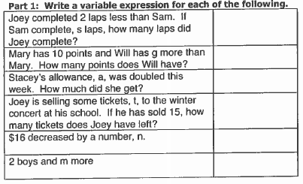

Review: Find the rule and next three terms.

25, 32, 28, 35, 31, 38

Variables/Open Sentences HW
TUESDAY
Answer the following test formatted questions involving variables.

1 Which represents the unknown value in the following statement? s + 3 = 12
A + C 3
B s D 12

2 Nick is paid $6.00 per hour, and last week he earned $150.00. What does the x represent in the equation 6x = 150 ?
F The number of hours Nick worked yesterday
G The number of days Nick worked last month
H The number of hours Nick worked last week
J The number of days Nick worked last week

3 Tammy has 96 markers that she is placing into bags for a class project. She places 8 markers in each bag. Which number sentence shows the number of bags, n, she will need?

F 8 + n = 96 H 8 ÷ n = 96

G 96 × 8 = n J 96 ÷ 8 = n

4 Bonnie earns $8 per hour from her job at the ice cream shop. Last week her paycheck was $80. Which number sentence could be used to find h, the number of hours Bonnie worked?

A h x 8 = 80 C h − 8 = 80

B h + 8 = 80 D h ÷ 8 = 80

WEDNESDAY

1. Explain what an open sentence is: _____________________

Directions: Draw the model for each of the following using the key then write the value for r.

Key: = r = 1

1. r + 2 = 9  =  r = _____ | 2. 6 + r = 11  =  r = _____
3. 6 – 5 = r  =  r = _____ | 4. 15 – 2 = r  =  r = _____

Review: Solve the following decimal computation problems.

5) 638.27 + 78.94 6) 4.9 – 2.78 7) 6.7 x 3.8

www.forrestmath.weebly.com

THURSDAY
Directions: Write an equation for the model below.
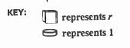
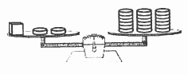

Equation _____________________

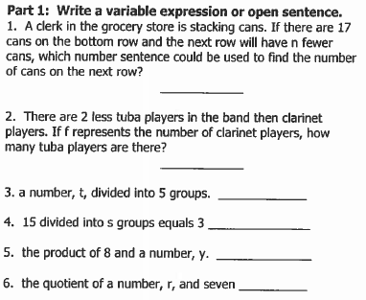

Review
Ryan went to the movies. He bought a movie ticket for $3.50, a soda for $2, and two boxes of popcorn for $2.50 each. If Ryan paid with a twenty-dollar bill, how much change did he receive?

