Name _______________________ Stem and Leaf HW #1
Part I: Fill in the product or quotient for each of the following.

1 8 x 8 = ______ 2 4 x 7= _______ 3 3 x 6= ________ 4 5 x 4= _______

5 6 x 4= ______ 6 9 x 8= _______ 7 2 x 7= ________ 8 6 x 6= _______

9 72 ~ 9= ______ 10 32 ~ 4= ____ 11 45 ~ 9= _____ 12 42 ~ 6= _____

13 48 ~ 8= _____ 14 16 ~ 4= ____ 15 16 ~ 2= _____ 16 81 ~ 9= _____

Part II: Use the line graph below to answer the following questions.
The line graph below shows how many points the Center City panthers scored during each of their football games last season.
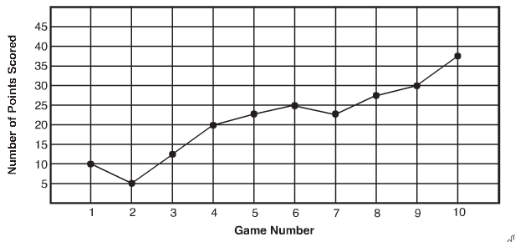

1 In which game did the Panthers score the most points? __________________________________

2 How many points were scored in all in games number 2, 4, 6, and 9? _______________________

3 In which game did the Panthers score the least number of points? _________________________

4 Did the Panthers improve in their scoring by the end of the year? __________________________
Part III: Use the data below to fill in the stem-and-leaf plot.
Stem | Leaf
43 87 54 67 58

88 83 69 50 48

** Remember to write the numbers from smallest to largest first.
Stem and Leaf HW #2
Part 1: Use the information to make a stem-and-leaf plot. Then answer the questions.
Johnny spent his summer mowing lawns. He made a lot of money. In one month he received $5, $25, $3, $17, $23, $13, $10, $1, $2, $15, $25, $22, $32 for all the lawns he mowed.

Stem | Leaf

1. What is the most money Johnny made for mowing a lawn? ______________________________

2. What is the least money Johnny made for mowing a lawn? ______________________________

3. Which interval has the most amounts? _______________________________________________

4. What is the total amount of money Johnny earned over the summer? ______________________

Part II: Use the data to fill in the stem-and-leaf plot.

Stem | Leaf

25 32 44 56 20 31

46 25 53 29 14 37

** Remember to write the numbers from smallest to largest first.

________________________________________

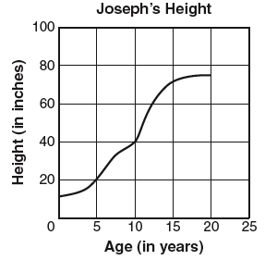
Part 3: Use the line graph to answer the questions.
The line graph shows how Joseph’s height changed.
1. How tall was Joseph when he was 15 years old? ______

2. How many inches did Joseph grow between five and

ten years of age? _________

3. During which five year period did Joseph grow the:

most? __________________ least? __________________

www.forrestmath.weebly.com
Stem and Leaf HW #3
Directions: Solve the following test formatted questions below.
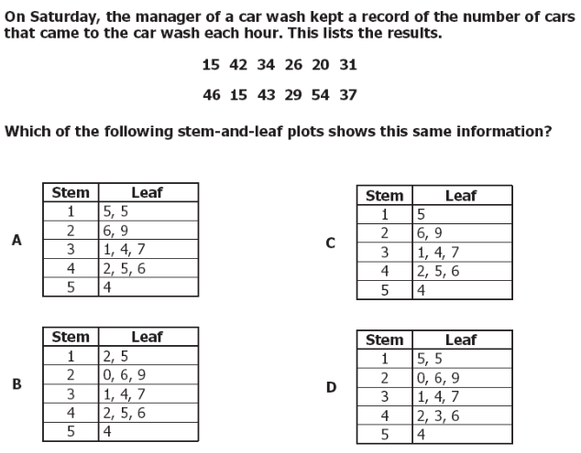
1.

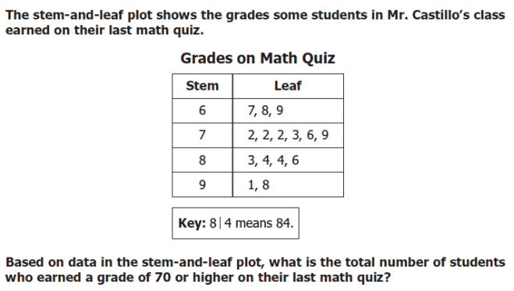
2.

