Name ________________________________________________________
MONDAY
Part 1: Convert the following fractions to decimals

1. 5/12 2. 8/9 3. 7/11

4. Write the fractions in order from least to greatest.
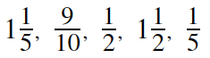

____________________________________________________

5. Write the fractions and decimals in order from greatest to least.

0.25, 0.333, 1* , 5^ , 0.8

____________________________________________________

1@
6. Using 1 and as a benchmark, place the following fractions in order from least to greatest.
12$
3(
4! @
12*

____________________________________________________
0 1 2

Convert the following fractions into decimals and then compare the decimals:
1. 3/5 and 6/9 2. 2/3 and 8/10

SOL Review HW #1
TUESDAY
Part I: Solve the following problems involving fractions and mixed numbers.

1. Heather read ¼ of a book on Thursday and 2/5 of the remainder on Friday. If 36 pages remained unread, how many pages are there in this book altogether?

2. Mrs. Johnson ordered 10 pizzas for her son’s birthday party. The kids at the party ate $4\frac{7}{8}$ pizzas and the adults had $3\frac{1}{2}$of the pizza. How much pizza did Mrs. Johnson have left?

3. Tony bought 5 feet of rope to tie up the trees that fell in his yard.
- On Monday he used $2\frac{4}{5}$ of a foot to make one bundle.
- On Tuesday he used 1$\frac{1}{3}$ of a foot to make another bundle.

How much rope will he have left if he wants to make another bundle of wood on Wednesday?

WEDNEDSAY
Part I: Solve the following problems involving decimals.
1. Tami, Julie, and Judy together painted their house. Jami painted for 4.25 hours, Julie for 2.75 hours and Judy for 3.33 hours. What was the total number of hours they painted?

2. Mrs. Townsend went to the grocery store to get a few things for the week. She bought:

- 4 packs of marshmallows for $0.99 each
- 2 boxes of graham crackers for $1.53 each

She paid the cashier with a twenty-dollar bill. How much change did she receive?

3. The tennis team sold bottles of water for $1.50 each. They sold 30 bottles on Saturday and 25 bottles on Sunday. How much money did they collect?

4. Mrs. Whetsel set a goal to walk 8 miles each week. She walked 1.653 miles on Monday and 2.15 miles on Tuesday. She plans to walk an equal distance for each of the next three days. How far will she have to walk on each of those days to meet her goal?
Test Practice
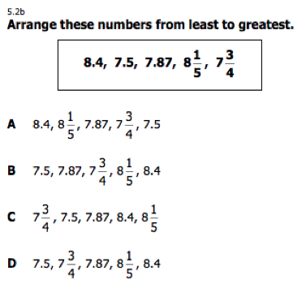
THURSDAY
1.

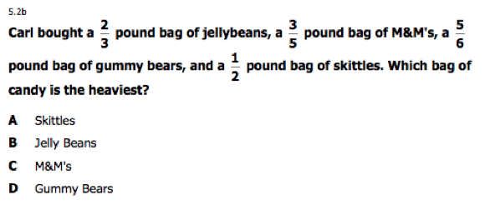

2.

