Name ________________________________
MONDAY – even/odd/prime/composite
Part I: Circle all of the even numbers below

80 41 649

98 75 732

2 33 383

Part II: List five 3-digit odd numbers below

______, ______, ______ ,______, ______

Part III: 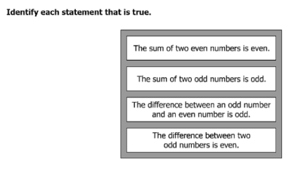
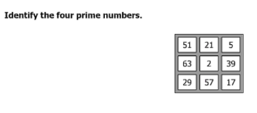
Part IV:

1st Quarter Review HW
TUESDAY – order of operations
Part I: List the steps in the order of operation.

__________ _____ or ______ ______ or _______

Part II: Evaluate the expression

40 – 20 ÷ 4 + 6

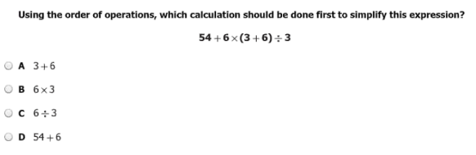
Part III:

Based on the order of operations, what should be the first calculation in simplifying 6(5 ÷ 3 x 2) ÷ 2 + 7

________________________

Solve.
4. 8(6 – 3) + 2 ÷ 2

www.forrestmath.weebly.com
WEDNESDAY – distributive property

1. To distribute means: ______________________________
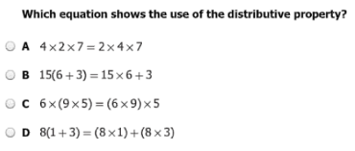
2.

3. Circle all of the equations that show the distributive property.

2 (5 + 3) = (2 x 5) + (2 x 3) (5 x 4) x 9 = 5 x (4 x 9)

(6 + 2) + 4 = 6 + (2 + 4) 3 x 5 x 7 = 7 x 3 x 5

7 + 6 + 1 = 6 + 7 + 1 (9 x 8) + (9 x 3) = 9 (8 + 3)

4. Which of the following makes the statement true?

9 x 67 =

A (9 x 60) + (9 x 7)
B 9 + (60 + 7)
C (9 x 60) + 7
D 9 (60 x 7)

www.forrestmath.weebly.com
THURSDAY – computation word problems (+ - x ÷)

1. Hannah’s family bought some supplies for their summer beach trip.
  - They bought four beach chairs that each cost the same amount for a total of $96.
  - They bought four beach umbrellas that each cost the same amount for a total of $156.

What was the combined cost of one chair and one umbrella?

A $252 B $60 C $63 D $15

2. Michael needs to earn $159. He charges $15 per lawn. Will he have enough money if he mows 7 lawns?

__________

3. The farmer’s market needs to sell 2, 345 pumpkins over the weekend to break even. How many pumpkins does the market need to sell Friday, Saturday and Sunday to meet their goal?

__________

4. Katie is placing her seashell collection in a special case. There are 5 compartments in the case. She can fit 12 shells in each compartment. She has already put 25 shells in the case. How many more shells can she fit?

A 32
B 35
C 45
D 60

