Name ____________________________________
TUESDAY

Part I: Define perimeter

1) Describe what perimeter is ___________________________
____________________________________________________

2) Tell how you calculate the perimeter of an object ____________________________________________________

Part II: Calculate the perimeter of the following objects by counting unit spaces.
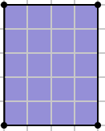
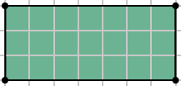
3) 4)

Part III: Calculate the perimeter of the following objects.

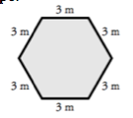
5) 6)
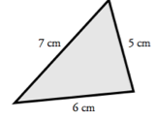

Finding Perimeter

Part I: Find the perimeter of the following objects.

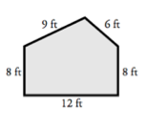
1) 2)
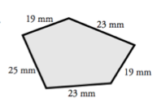

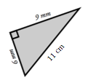
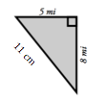
3) 4)

Part II: Determine the perimeter. Draw the shape if necessary.

5) A square piece of paper has sides that are 6 inches long. What is the perimeter of the piece of paper? ____________

6) My fence is 10 feet long and 15 feet wide. What is the perimeter of my fence? _______________

www.forrestmath.weebly.com

WEDNESDAY
Part I: Use the centimeter ruler provided to measure and calculate the perimeter of the following objects.
1) 2)

_____________ ______________

3) 4)
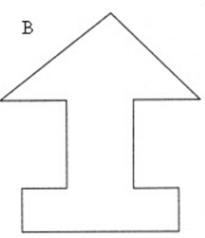
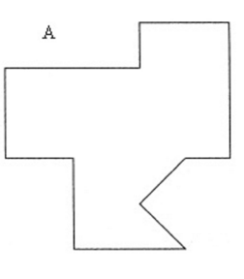

www.forrestmath.weebly.com

THURSDAY
Define
1. Explain how you find the perimeter of an object:
_________________________________________________

2. Explain how you find the area of a right triangle:
_________________________________________________

3. Explain how you find the area of a rectangle or square:
_________________________________________________

Find the area of each rectangle.

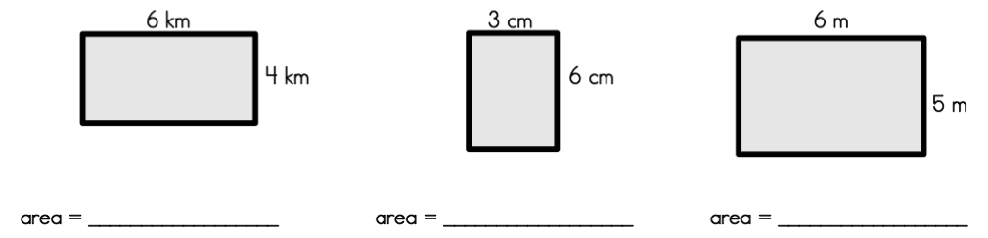

Calculate the following

4. What would the area of a right triangle with the sides measuring 12 cm. and 20 cm. be? _____________

5. Find the perimeter of a square with the length of 13 in. and width of 16 in. _____________

6. Ms. Porter covered her bulletin board with pink paper. The area that she covered was a total of 120 inches². What could have been the measurements of her bulletin board?

A) 40 in. by 30 in. B) 40 in. by 3 in.
C) 60 in. by 60 in. D) 30 in. by 400 in.

