Name _________________________________
MONDAY
Part I: Fill in the next two figures in the patterns below.
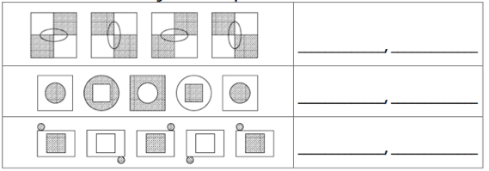

Part II: Find the rule for each function table.
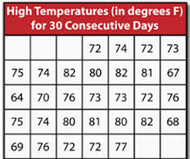
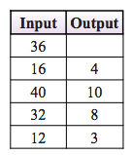
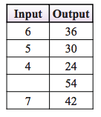

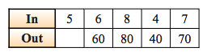

Stem | Leaf

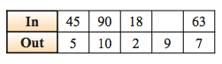

Patterns HW
TUESDAY
Part I: Look at the pattern to answer the following.

What would be the sixteenth item in this pattern?

Part II - Review: use the data below to create a stem/leaf plot.

WEDNESDAY
Part I: Use the table to answer the following question.
Number of Hamburgers | Total Cost
1 | $2.25
2 | $4.50
3 | $6.75
4
5 | $11.25

1) Using the table above, what would be the cost of four hamburgers?
__________

2) Which best describes the location of X on the number line?
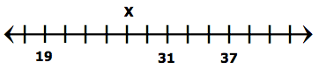

A) 25 B) 27 C) 29 D) 30

Part II: What number is missing from the sequence?

3) 4, ____, 16, 32, 64, 128

4) 1, 5, _____, 125, 625, 3125

5) 1, 2, 5, 10, 17, 26, 37, _____

www.forrestmath.weebly.com
THURSDAY
Directions: Create the pattern and then find the rule.

