Name _________________________________
MONDAY
Part I: Use two colors to shade the flat to show the following multiplication problems.
0.3 x 0.9 0.1 x 0.3

Part II: Round the following numbers in the chart below.

NUMBER | Nearest whole number | Nearest tenth | Nearest hundredth
3.746
23.806
0.957

Part III: Review

6. 860,148 7. 800,184
+ 791,572 - 725,235

www.forrestmath.weebly.com
Mult/Div Decimals HW
TUESDAY
Part I: Solve the following multiplication problems
1. 7.2 2. 2.3 3. 5.9
x 58 x .89 x 5

4. 3.7 5. .85
x .90 x .29

How is multiplying whole numbers similar to multiplying decimals? ___________________________________________
________________________________________________________________________________________________________

How is multiplying whole numbers different from multiplying decimals? __________________________________________
________________________________________________________________________________________________________

Part II: Review
Actual Answer | Estimate | Actual Answer | Estimate
1.  954,620  + 63,814 | 1. | 2.  27,854  + 5,249 | 2.

WEDNESDAY
Part I: Divide. Be sure to show how you got your answers.

What are the steps of division (HINT: there are SIX!)

_________, __________, __________, __________,
__________, _________

1) 3.25 ÷ 3 2) 6 t12.09

3) 7.483 divided by 4

Part II: Review. Shade the grids to represent the decimals below them.

0.47 0.04

THURSDAY – Test Prep

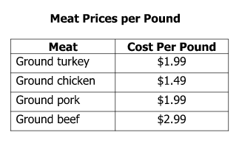
1) Mrs. Williams purchased 3 pounds of ground beef and 1 pound of ground pork.

Since the prices include tax, what is the best estimate for the total cost of the beef and pork?

F $11.00 G $12.00 H $13.00 J $14.00

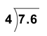

2)

F 19 G 18 H 1.9 J 1.8

3) 4.5 × 1.4 =

F) 0.063

G) 0.63

H) 6.3

J ) 63

