Name __________________________________ Mean, Median, Mode, Range HW #1
Stem and Leaf/Order of Operations Review

Directions: Use the data to create a stem and leaf plot. Then choose the statements that are true about the data.

Sasha collected data on the amount of time in seconds that it took the first graders in Mrs. Holmes class to tie their shoes. Her data is listed below:
56, 45, 78, 98, 64, 56, 79, 80, 97, 47, 59,
86, 67, 52, 41, 70, 82, 52, 40, 64, 61, 80

Create a stem a leaf plot to display the data. Circle all of the statements that are true.

At least one student can tie their shoes in less than 40 seconds.

Nine students can tie their shoes in less than 1 minute.

Most students take more than 70 seconds to tie their shoes.

The fastest student can tie their shoes in 40 seconds.

The slowest student can tie their shoes in 90 seconds.

Mrs. Holmes met a goal of all of her students tying their shoes in 90 seconds or less.

There are more students tying their shoes in the 80 interval than the 90 interval.
Stem Leaf

Directions: Use the data to create a stem and leaf plot. Then answer the questions.

Destiny conducted an experiment to see how long, in seconds, each student in her class could hold their breath. Her data is listed below:
83, 86, 92, 13, 28, 53, 49, 28, 49, 66, 50,
81, 18, 27, 68, 81, 45, 53, 21, 17, 55, 80

She created the stem and leaf plot below. Use it to answer the questions below.
Destiny’s plot Your plot
1. Is her stem and leaf plot correct? ________
If not, what mistake(s) did she make?
___________________________________________
___________________________________________

2. Using your plot, how many student can hold their breath for more than 1 minute (60 seconds)? ______

3. What is the difference between the longest and the shortest times? _________

4. How many students can hold their breath for less than 50 seconds? ______
Stem Leaf

Stem Leaf
1 3, 7, 8
2 1, 7, 8
3 0
4 5, 9, 9
5 0, 3, 5
6 6, 8
7 0
8 0, 1, 3, 6
9 2

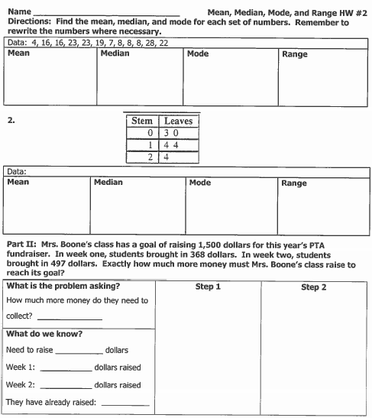

www.forrestmath.weebly.com

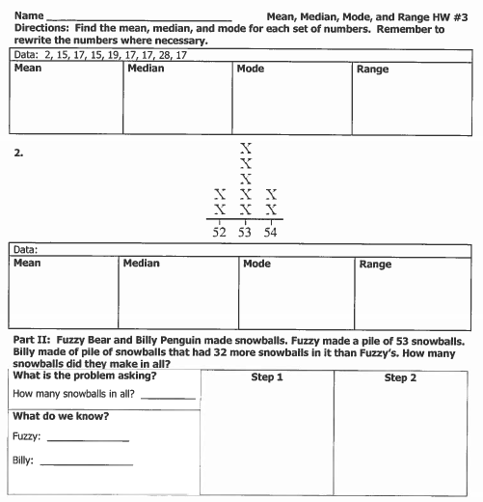

click

www.forrestmath.weebly.com

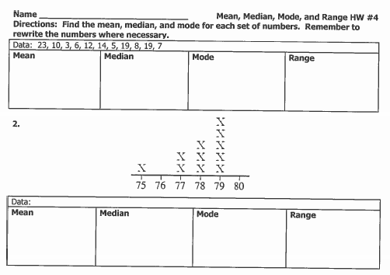

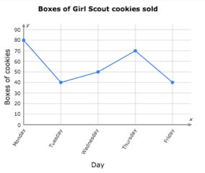

Review: Line Graphs

3. Did the number of cookies sold increase or decrease between Tuesday and Thursday? _________

4. What is the best day to sell Girl Scout cookies? ______________________

5. How many boxes of Girl Scout cookies were sold this week? _____________

