Name _________________________________________________________
TUESDAY
Part I: Describe.
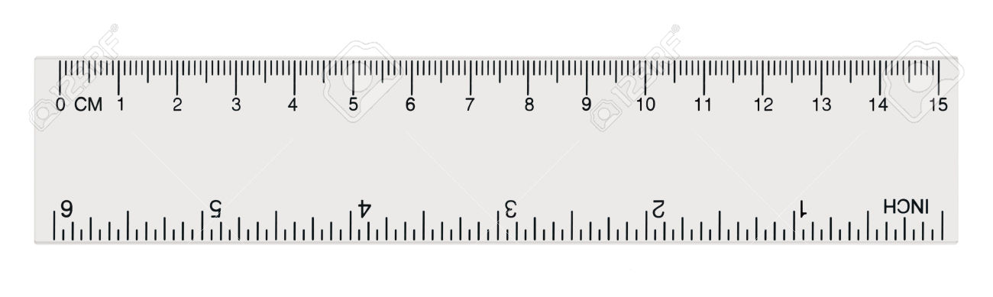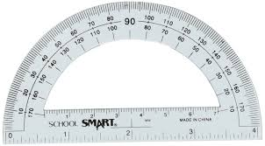
1. In your own words, tell me how a protractor and a ruler are different _________________________________________________________________
________________________________________________________________________________________________________________________________________________________
2. How are they similar? _______________________________________________
________________________________________________________________________________________________________________________________________________________
Part II: Using the protractor provided, measure the following angles. Indicate whether the angels are acute, obtuse, or right.
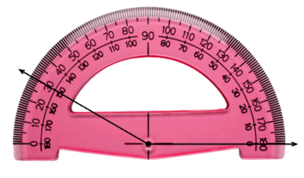
3.

____________________________

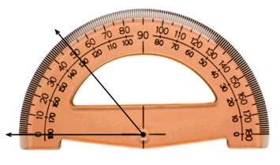
4.

____________________________

Measuring Angles/Angles as Additives HW
Part I: Define.
1. All straight angles equal _________ degrees.

Part II: Find the value of the missing angle.

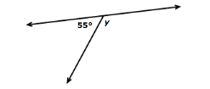
2. angle y = ____________

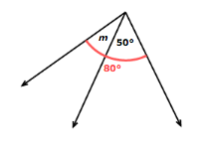
3. angle m = ____________

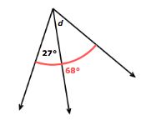
4. angle d = ____________

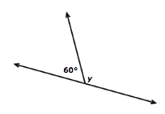
5. angle y = ____________

www.forrestmath.weebly.com
WEDNESDAY
Name and measure each angle.
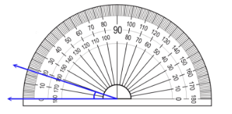
1.

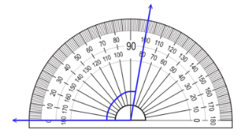
2.

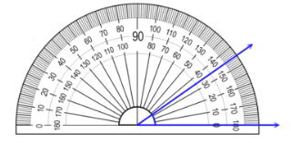
3.

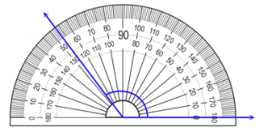
4.

www.forrestmath.weebly.com

THURSDAY
Part I: Answer the following test-formatted questions.
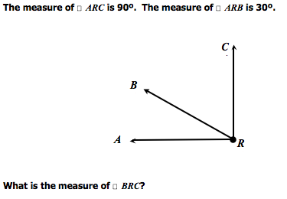
1.

_________________

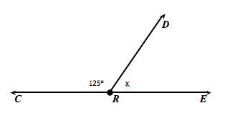
2. The sum of angle CDR and angle ERD is 180 degrees.

Which equation could be used to find the value of the unknown angle?

