Name _______________________________________
TUESDAY
Part I: Write the units used to measure length in order from smallest to largest.

Metric System U.S. Customary

1. _____________________ 1. ______________________

2. _____________________ 2. ______________________

3. _____________________ 3. ______________________

4. _____________________ 4. ______________________

1. Mason needs to measure the width of his bedroom. Which of the following units would be best for Mason to use to measure the width of his bedroom?
A millimeters C feet
B centimeters D miles

2. Joanna wants to know how long her big toe is. Which of the following measurements could be the length of Joanna’s big toe?
F 45 millimeters H 10 centimeters
G 45 inches J 10 feet

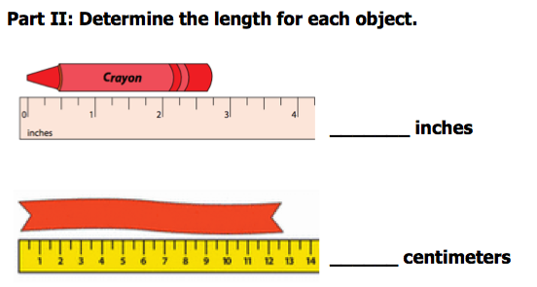

Length and Weight HW
Part I: Convert the following measurements.
(Hint: write down the relationship, what you already know about the units)

1. 3 feet = _____ inches 2. 30 mm = ____ cm

3. 60 inches = ____ feet 4. 7 cm = ____ mm

5. 7 km = ____ meters 6. 4500 m = ____ km

Part II: Measure the following items. Write the exact measurement.

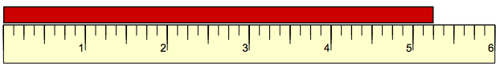
1.

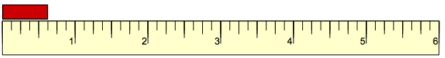
2.

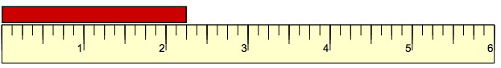
3.

Part III: Please tell me in a complete sentence what is wrong with this measurement.
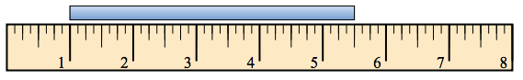
4.

www.forrestmath.weebly.com Twitter @ForrestMath1406

WEDNESDAY
Part I: Write the units used to measure mass/weight in order from smallest to largest.

Metric System U.S. Customary
1. _____________________ 1. ______________________
2. _____________________ 2. ______________________
3. ______________________

Part II: Circle the best unit to measure each of the following.

1. a math textbook ounce or pound

2. a pear ounce or pound

3. a television gram or kilogram

4. a slice of bread gram or kilogram

Part III: Convert the following (hint: write down the relationship between the two units using your notes!)
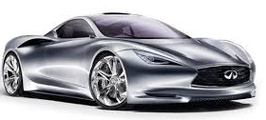
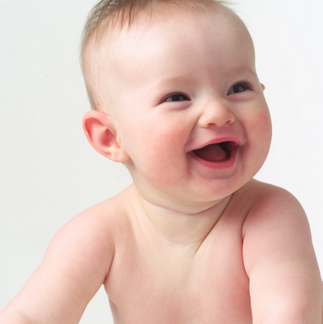
1. 2.

The baby weighs 7 pounds. The car weighs 4 tons.
How many ounces is that? How many pounds?
______ ________
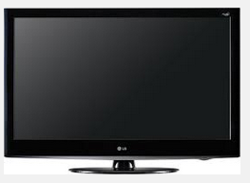
The book weighs 48 oz. How many pounds is that? _____
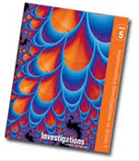
3. 4.
The TV has a mass of 6,000 grams. How many Kilograms? ________

THURSDAY
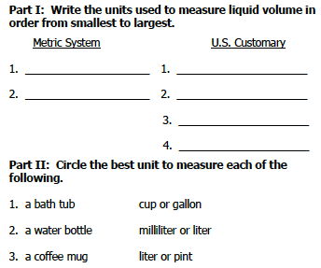

Part III: Complete the following conversion table.
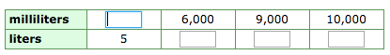

Part IV: Convert the following units.

1) 2,000 milliliters = _____ liters

2) Which is more: 4,000 milliliters or 4 liters?

3) 10 liters = _____ milliliters

