Name _________________________________
MONDAY
Part I: Creating a line plot
The list below shows the height in inches of each student in Monika’s class.

45, 48, 46, 47, 45, 50, 45, 46, 46, 51, 48, 48, 46

Use this data to create a line plot. Then answer the questions below.

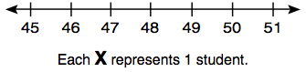

2. How many students are 46 inches tall? _________________

3. How many students are at least 48 inches tall? __________

4. How many students are either 45 or 48 inches? _________

5. How many students are in Monika’s class? ______________

Review: Find the mean, median, mode, and range for the data set above.

www.forrestmath.weebly.com
Line Plot HW
TUESDAY
Part I: Analyzing (understanding) a line plot
The line plot below shows the number of books each student in Tavon’s class read over the summer.

1. What is the most books a student read? ________________

2. How many students read less than 3 books? ____________

Write true (T) or false (F) for each of the following.

________ Two more students read 3 books than 5 books.

________ Seven students read at least six books.

________ There are twenty-five students in Tavon’s class.

Review: create a stem and leaf plot using the data from the line plot above.

WEDNESDAY
Part I: Create and analyze a line plot
The percentages of scores of all the students in a class are shown in the table. Place this data on the line plot below.
Test Scores
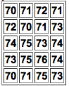

[ccccccc]

76
75
74
73
72
71
70
Each X represents 1 student

1. How many students scored a 75% or higher? ____________

2. Two students scored a _________ percent.

3. How many more students scored a 73% than a 76%? ____

4. What was the lowest score in the class? ________________

5. What was the highest score in the class? _______________

Review: Create a stem and leaf plot using the test score data above.

THURSDAY
Part I: Using the data below, create a line plot.

Alyssa made this list to show the number of pets 10 students own.

1, 0, 5, 1, 4, 1, 2, 0, 4, 1

Pets Owned

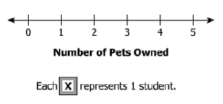

1. How many more students owned 1 pet than 0 pets? ______

2. How many students own 5 pets? ________________

3. How many students owned more than 1 pet? __________

Review: Find the mean, median, mode, and range for the data set above.

