[](http://www.screenchomp.com/t/3wiVeqLfF2)**Name _____________________________**

**TUESDAY**

**Part I: covert the following fractions into decimals by using division. See example for help.**

1. 5/10 2. 4/6 3. 7/9

**example**

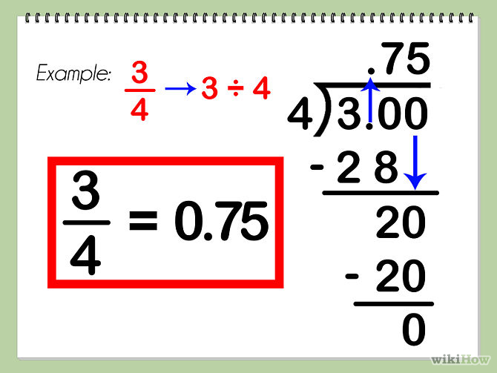

**Review**

Zach saved $19 in March. He saved $42 in April and $41 in May. Then Zach spent $82 on a keyboard. How much money does Zach have left?

|  |  |  |
| --- | --- | --- |
| **Step 1** | **Step 2** | **Step 3** |
|  |  |  |

**Shade the figures to make equivalent fractions.**

2. l=r 3. l=e4. C=a 5. T=p

www.forrestmath.weebly.com

**Fraction/Decimal Equivalence**

**WEDNESDAY**

**Part I: Convert the following fractions to decimals**

1. 3/5 2. 4/12 3. 6/8

**Review**

1. On a Friday evening a pizza shop had orders for 4 pepperoni, 97 vegetable, and 335 cheese pizzas. If the 4 cooks each made an equal number of pizzas, how many pizzas did each cook make? (2 steps!)

**Round each of the following decimals to the nearest tenth.**

**1.** 2.36 _______ **2.**  45.19 ______ **3.** 5.321 ______

**Round each of the following to the nearest whole number.**

**4.** 23.14 _______ **5.** 3.962 ______ **6.** 68.49 ______

**Solve**

**7.** What is the product of 7 and 4.38?

**THURSDAY**

**Part I: Convert the following fractions into decimals and then compare the decimals:**

1. 3/5 and 6/9 2. 2/3 and 8/10

2. **Look at the number line drawn below. What is the decimal value of A?**

A

| | | | | |

0 1

**A** 0.80 **B** 0.60 **C** 0.40 **D** 0.20

3. **Karla ate  of her pizza. Which model shows  as a decimal?**

## **F** d **G** g **H** h **J** j

4. **Paul needs  quart of oil in his car. Which of the following amounts is equivalent to  quart?**

**A** 0.25 quart **B** 0.50 quart

**C** 0.75 quart **D** 0.80 quart

[www.forrestmath.weebly.com](http://www.forrestmath.weebly.com)