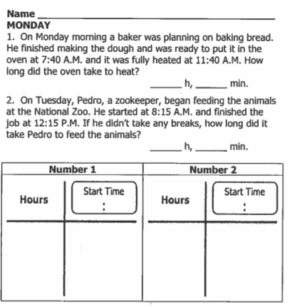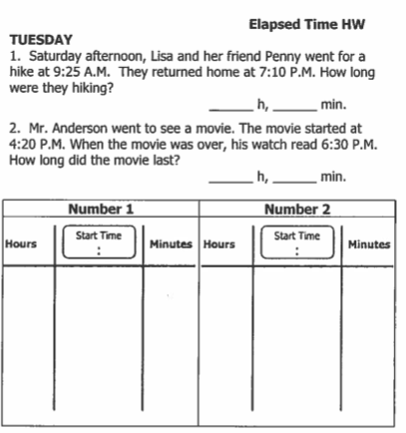

**www.forrestmath.weebly.com**



**Review: Use the line graph below to answer the following questions**

**3.**

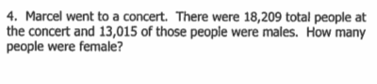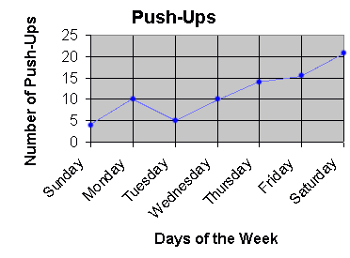

3. What is the **scale** counting by? ________

4. What is the **trend** of this data? _______________________________________________

5. How many push-ups were done this week? _________________

6. How many more push-ups were done on Friday than on Sunday and Tuesday combined? ______________________

**Review: Use the line graph below to answer the following questions**

**3.**

