Name _________________________________________________________
MONDAY
Part I: Solve the following problems.

1) 63,210 2) 21
- 11,799 x 43

3) 7 r2 8 5 4) 12,237
+ 7, 199

Part II: Solve the following word problems. Annotate the important verbs and show how you solve each problem!

- Karen noticed that a hamburger at a fast food restaurant has 688 calories. A small order of fries has the same number of calories. If Karen eats a hamburger and two small orders of fries, how many total calories will she put in her body?

- The square footage of Stacey’s house is 3,252. The square footage of Bob’s house is 2,067. How much bigger is Stacey’s house than Bob’s house?

- Sophie enjoys reading. Over the past week and a half, Sophie has read seven books with a total of 966 pages. If all seven books have the same number of pages, how many pages were in each book?

- Kellli bought a new photo album to display her vacation pictures. Each page of the album displays six photos. There are a total of 143 pages in the book. How many photos can the album hold?
Computation/Distributive Property HW
TUESDAY
Part I: Solve the following problems involving two digit divisors.

1) 25 e256 2) 10 e540 3) 18 e137

Part II: Solve the following word problems. Remember to estimate the divisors to help get started.

4) Eve needs to order 925 cookies for a banquet that she’s hosting. If the cookies come in boxes of 15, how many boxes will she need to order?

5) Ms. Thomas can make 5,985 paper copies. She uses the paper to make homework packets for her students. If Ms. Thomas has 45 students, how many homework packets can she make?

www.forrestmath.weebly.com
WEDNESDAY
Part I: Define

Using your own words, what does it mean to distribute?
________________________________

Part II: Represent the distributive property
Directions: use squares to show the distributive property

1. 2 (3 + 2)

2. 3 x (4 + 1)

3. 5 (2 + 2)

Part III:
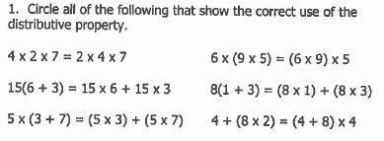

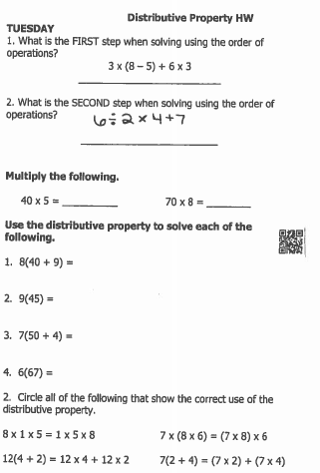
THURSDAY

