Name _________________________________
TUESDAY
Part I: Create a place value chart below. Include whole number places to millions and decimal places to thousandths.

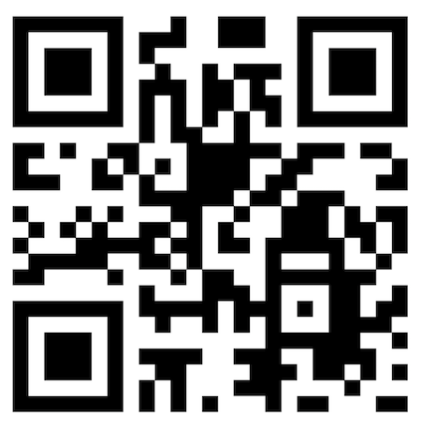
Part II: Write the standard form for each.

Word Form | Standard Form
Twelve and sixty-two hundredths

Six and eight thousandths

Three and seven tenths

Forty-two and sixteen hundredths

Eight and nine hundredths

Six hundred two and eight hundred forty thousandths

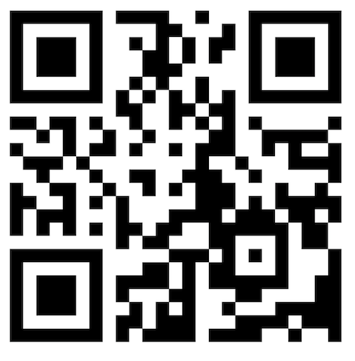
Part III: Shade the grids to represent the decimals above them.

0.47 0.28 0.7 0.04

Decimal PV and Rounding HW
WEDNESDAY
Part I: Match the standard form with the correct word form.
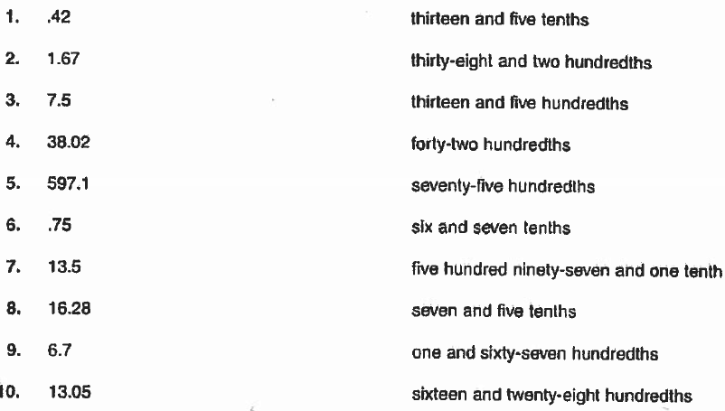
Part II: Round the following decimals to the specified place value. And show how you figured out your answer!

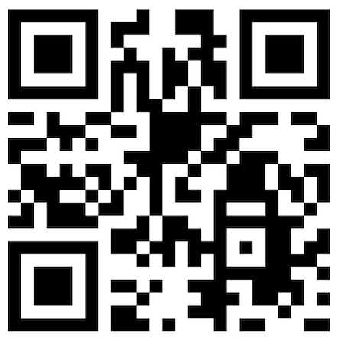
Round each of the following decimals to the nearest tenth.

1. 2.36 ___________ 2. 45.19 ____________

3. 5.321 ___________ 4. 5.91 _____________

Round each of the following decimals to the nearest hundredth

5. 78.19 ____________ 6. 0.426 _____________

Round each of the following to the nearest whole number.

7. 23.14 __________ 8. 3.962 ____________
9. 68.49 ___________
www.forrestmath.weebly.com
THURSDAY
Part I: Fill in the chart below by rounding each number to the place values specified.

Number | Tenth | Hundredth | Whole Number
43.891

55.69

124.9

Part II: Round to the specific place.
Round each of the following decimals to the nearest tenth.

1. 3.495 ___________ 2. 27.93 ____________
3. 2.36 ___________

Round each of the following to the nearest whole number.

1. 45.86 __________ 2. 13.428 ____________
3. 23.14 ___________

Part III: Review
Solve the following.

Darius wanted to read 500 pages in his book by the end of the week. He read 123 pages on Monday, 142 pages on Tuesday, and 89 pages on Wednesday. How many more pages does he need to read to reach his goal of 500 pages read?

www.forrestmath.weebly.com
Test Practice

1. When rounded to the nearest tenth, which of the following decimals would round to 740.39?

F) 740,398 G) 740,391

H) 740.387 J) 740.139

2. Judy started with 3.456. Her rounded answer was 3.46. To what place did she round this number?
______________________

3. True or False? 6.675 rounded to the nearest hundredth is 6.67. Prove your answer.

____________________________________________

4. Which of the following shows 7.995 rounded to the nearest tenth?

A) 8.0 B) 7.99

C) 7.9 D) 7.09

5. Which of the following shows 7.995 rounded to the nearest tenth?

A) 8.0 B) 7.99

C) 7.9 D) 7.09

