Name _______________________________________
MONDAY
Part I: cut out and combine (arrange) the shapes provided to create the house below. Take a picture of the house that you created with your shapes and email them to your teacher!
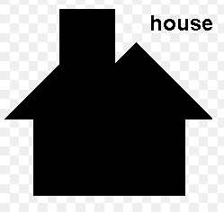

Part II: Use your circle notes to practice memorizing the following formulas.

1. Think about how the diameter and circumference are related. Write down how to find the circumference of a circle if you are given the diameter of 6 mm. _______________________________________

2. Think about how the diameter and circumference are related. Write down how to find the diameter of a circle if you are given the circumference of 30 cm. _________________________________________
www.forrestmath.weebly.com
Combine/Subdivide Shapes HW
TUESDAY
Part I: cut out and combine (arrange) the shapes provided to create the house below. Take a picture of the house that you created with your shapes and and email them to your teacher!
Part II: Use your circle notes to practice memorizing the following formulas.

1. Think about how the diameter and radius are related. Write down how to find the diameter if you are given the radius of 14 in.
_______________________________________

2. Think about how the diameter and radius are related. Write down how to find the radius if you are given the diameter of 28 ft.
_______________________________________

WEDNESDAY
Part I: cut out and combine (arrange) the shapes provided to create the house below. Take a picture of the house that you created with your shapes and email them to your teacher!
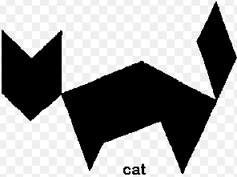

Part II: Use your circle notes to practice memorizing the following formulas.

1. Think about how the radius and circumference are related. Write down how you would find the circumference if you were given the radius of 14 m.
_____________________________

2. Think about how the radius and circumference are related. Write down how you would find the radius if you were given the circumference of 72 yds.
__________________________________________

THURSDAY
Part I: cut out and combine (arrange) the shapes provided to create the house below. Take a picture of the house that you created with your shapes and email them to your teacher!
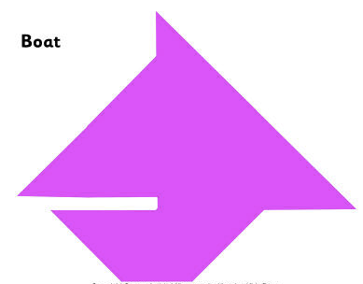

Part II: Use your circle notes to practice memorizing how the parts of a circle are related.

1. Think about how the chord and diameter are related. If the diameter is 57 cm., which of the following could be the measurements of a chord? Be sure to circle all possible measurements.
56 cm. 59 cm. 60 cm. 13 cm.

57 cm. 30 cm. 100 cm. 47 cm.

www.forrestmath.weebly.com

