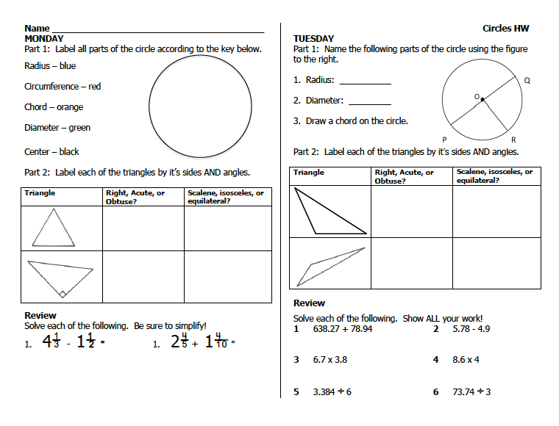

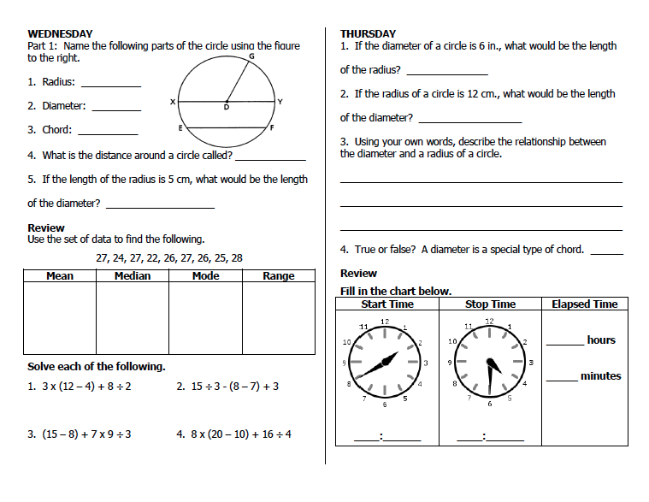

For videos on MMMR, Order of Operations, and Elapsed time, go to: www.forrestmath.weebly.com

