Name ________________________________
MONDAY
Directions: Using the formula base x height ÷ 2, find the area for the following right triangles.

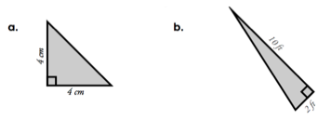
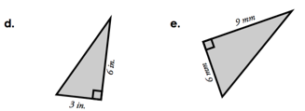

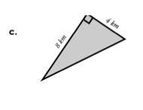

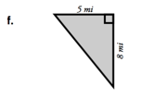

www.forrestmath.weebly.com
Area of Triangles/Volume
TUESDAY

1. Explain why you have to divide (base x height) by two in order to find the area of a triangle. ____________________________________________________
____________________________________________________

Directions: find the area for the following right triangles

2. 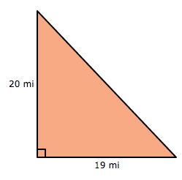 3. 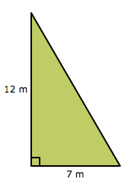

4. 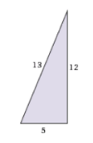 5. 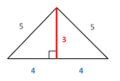

Write the formulas that you would use to find:

6. Perimeter - _____________________

7. Area of a Square/Rectangle - ________________________

WEDNESDAY
Part I: Write the formula that you use to find each of the following…

1) perimeter - _______________________________________

2) area of a square/rectangle -___________________________

3) area of a right triangle - _____________________________

4) volume of an figure - ________________________________

Part II: Find the volume of the following irregular figures made of cubes.

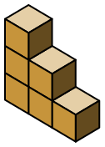
5) 6) 7)

____________ ___________ ___________

Part III: Review. Elapsed Time.

8) On Monday there wasn’t any traffic on the road when Mrs. Townsend left the house for a mini road trip. She arrived at her destination at 10:25 am and it took her 4 hours and 38 minutes to get there. What time did Mrs. Townsend leave the house?

www.forrestmath.weebly.com
THURSDAY
Part I: Find the volume of the following figures.

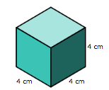
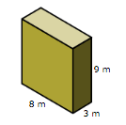
1) 2)

_________ ___________

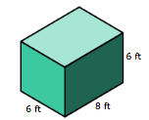
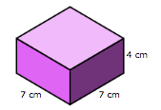
3) 4)

__________ ___________

Part I: Solve the following word problems involving volume.

1) I want to stack 8 books on a shelf. Each book is 19 cm. wide, 26 cm. long, and 2 cm. thick. What is the volume taken up by these books?

2) The ecology club is going to start recycling again at Forrest! The recycling bins look like the figure below.
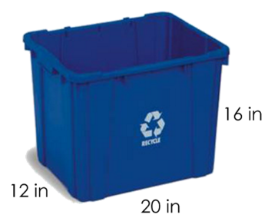
What is the volume of paper that one
recycling bin can hold? __________

What is the volume that 26 recycling bins
can hold? ____________

3) The dimensions of a fish tank are as follows: 13 inches long, 10 inches wide, and 17 inches deep. What is the volume of water that this fish tank can hold?

