Name __________________________________
MONDAY

- Which is closest to the measure of the angle shown?

A 50° C 165°

B 15° D 5°

2. Which of the following tools is used to measure angles?
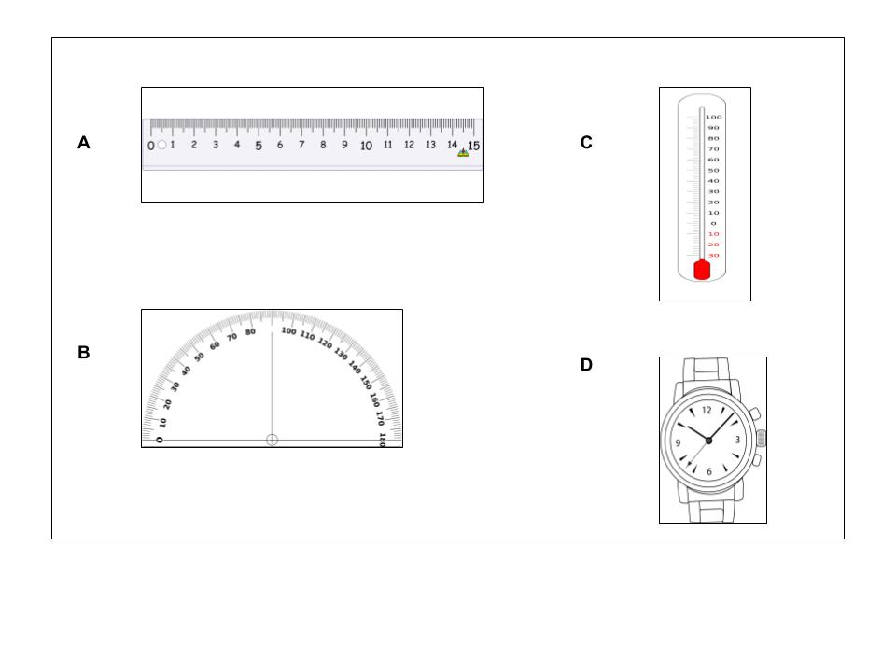

3. Which angle appears to be an obtuse angle?
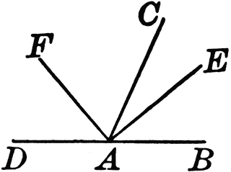

A Angle DAF C Angle EAD

B Angle CAE D Angle EAB

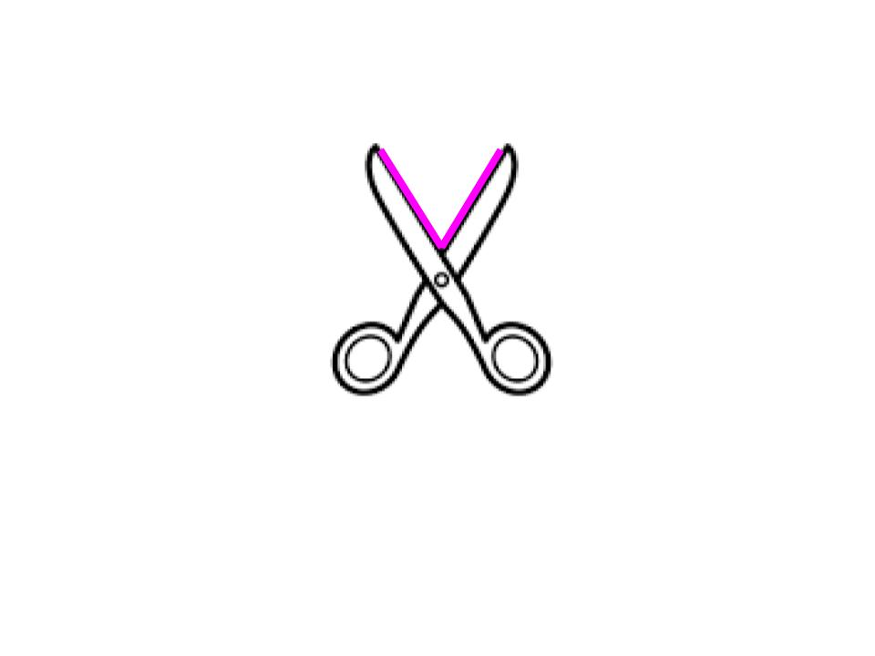
4. Which best describes the angle formed by the blades of the scissors?

A Acute B Straight

C Right D Obtuse
Angles/Triangles Review HW
TUESDAY

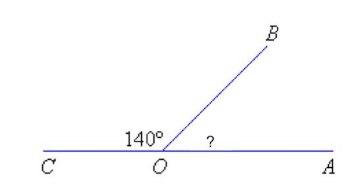
- The measure of angle COA is about 180°. Angle COB is 140°. What is closest to the measure of angle BOA?

__________degrees

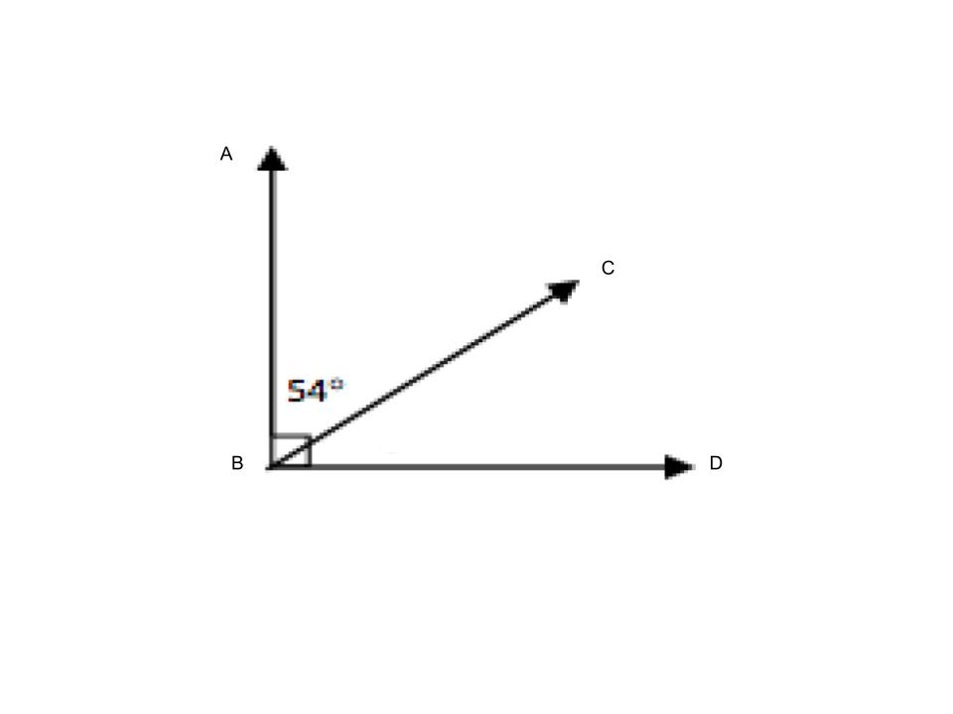
2. The sum of angles ABC and CBD is 90°. What equation can be used to find the unknown angle?

A 90 = 54 + x

B 90 = 54 – x

C 54 = 90 + x

D 54 = 90 – x

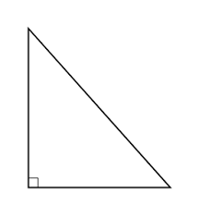
3. Which types of angles are used to form this triangle?

A right, obtuse C obtuse, acute

B right, right D right, acute

Review

1) 7 – 3.81 2) 4.61 - .9 3) 0.951 – 0.48

WEDNESDAY

- The picture shows 5 points on a grid.
Which points can be connected to form a right triangle?
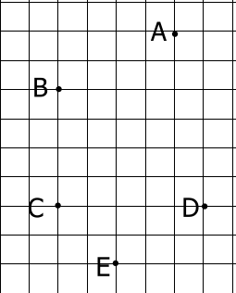

A Points B,A,D

B Points A, D, C

C Points B, C, D

D Points B,C,E

- What type of triangle has only 2 congruent sides?

A Scalene B Isosceles C Equilateral D Obtuse

3. Which side is congruent to side CA?

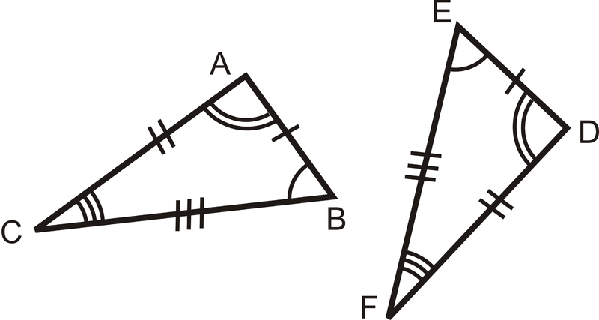
A Side ED

B Side EF

C Side DF

D Side AB

www.forrestmath.weebly.com

THURSDAY
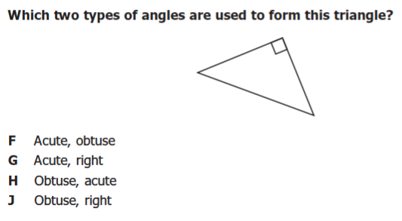
1.

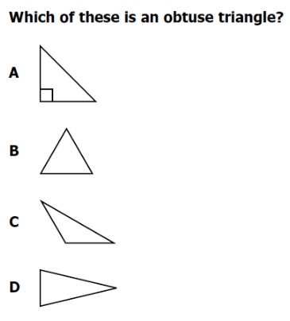

2.

