Name ____________________________________
MONDAY

Part I: Define perimeter

1) Describe what perimeter is ___________________________
____________________________________________________

2) Tell how you calculate the perimeter of an object ____________________________________________________

Part II: Calculate the perimeter of the following objects by counting unit spaces.
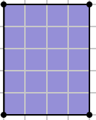
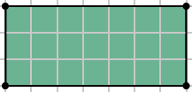
3) 4)

Part III: Calculate the perimeter of the following objects.

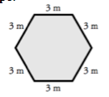
5) 6)
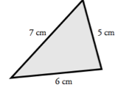

Finding Perimeter and Area
TUESDAY
Part I: Find the perimeter of the following objects.

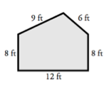
1) 2)
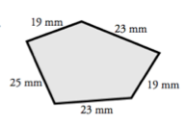

Part II: Determine the perimeter. Draw the shape if necessary.

5) A square piece of paper has sides that are 6 inches long. What is the perimeter of the piece of paper? ____________

6) My fence is 10 feet long and 15 feet wide. What is the perimeter of my fence? _______________

7) Explain how you find the area of a rectangle or square:
___________________

Find the area of each rectangle.

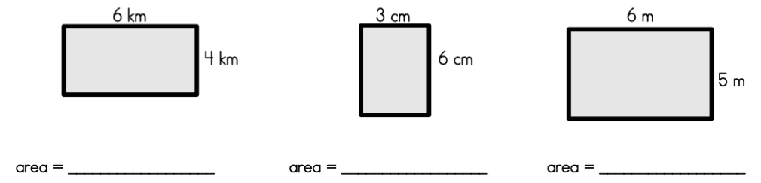

WEDNESDAY
Calculate:
4. What would the area of a rectangle with two sides measuring 12 cm. and 20 cm. be? _____________

5. Find the perimeter of a square with the length of 13 in. and width of 16 in. _____________

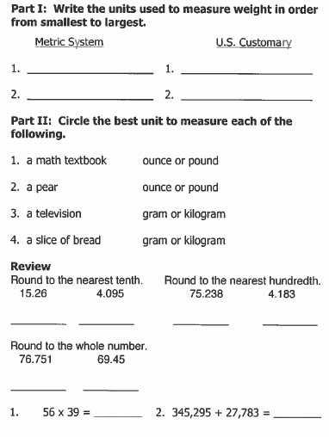

THURSDAY
Draw the Big “G”

