Name __________________________________________
MONDAY
Use the organizer to solve the following problem.

1. Zach saved $19 in March. He saved $42 in April and $41 in May. Then Zach spent $82 on a keyboard. How much money does Zach have left?

2. In this problem, the verb saved means to: add or subtract

3. In this problem, the verb spent means to: add or subtract

Solve
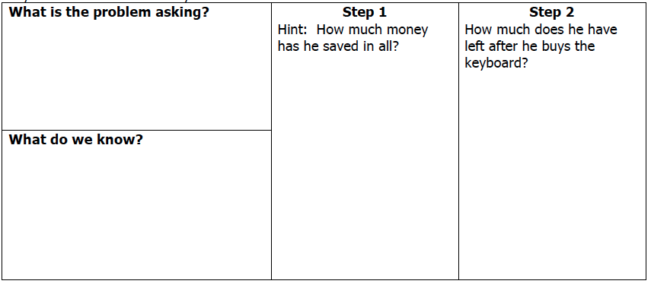

Review
Circle all of the numbers below that round to 56,200.

56,260 56,119 56,191

56,149 56,151 56,252

Connie put 4 apples in each basket. How many apples did she use altogether?
A 12 C 38

B 16 D 48
Word Problem HW
TUESDAY

Use the organizer to solve the following problem.

1. One troll stopped 53,570 people from crossing a bridge in 2007. He then stopped 52,980 people in 2008. A second troll stopped 200,101 people in 2007 and 201,600 people in 2008. How many more people were stopped in 2008 than in 2007?

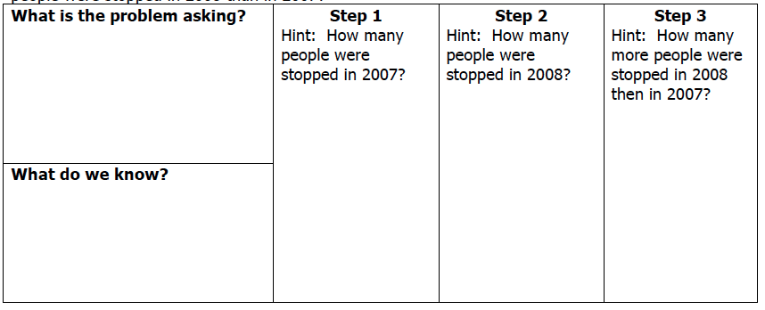

REVIEW – Facts and Rounding

2) 12 x 3 = ________ 2) 11 x 11 = ________ 3) 6 x 7 = _________

4) 8 x 9 = _______ 5) 42 ÷ 6 = ________ 6) 72 ÷ 9 = ________

Circle all of the following numbers that would round to 700,000

734,998 749,110 651,003

622,967 699,707 813,813

www.forrestmath.weebly.com

WEDNESDAY

Use the organizer to solve the following problem.

1. Jamila wants to see all 1,200 paintings in the museum. She saw 616 of them on Monday. On Tuesday, she saw 389 paintings. How many paintings does Jamila still need to see?
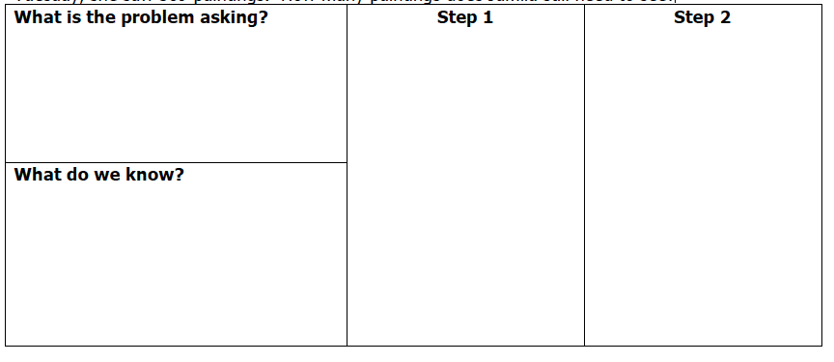

REVIEW – Adding/Subtracting with Estimation

2) Khyri was playing his favorite video game. On Monday he scored 17,689 points, on Tuesday he scored 54,721 points, and on Friday he scored 8,221 points. About how many points did he score this week?

 | Actual Answer | Estimated Answer
Combine 63,890 and 46,946.
What is the difference between 506,789 and 34,388?
THURSDAY

Solve the following problem.

1. I received $3,492 in my paycheck. After I pay $1,875 for my house and $552 for my car, do I have enough money to go on a weekend getaway that costs $925?

2. In this problem, what does the verb received mean? + or -

3. In this problem, what does the verb pay mean? + or -

Review
Complete each of the following to shows the correct use of the associative property?

( ___ + 7) + 8 = 2 + ( ___ + 8)

6 x ( ___ x 5) = (6 x 3) x ___

Complete each of the following to shows the correct use of the commutative property?

25 + 13 = ____ + 25

____ x 12 = 12 x 7

Place an “X” on all of the numbers that are common factors of 16 and 24.

6
1
2
3
4

24
16
10
8

www.forrestmath.weebly.com

