Name _______________________________
WEDNESDAY
Part I: Using partial quotients to divide
Today we learned how to use partial quotients in order to find the answer to a division problem. Use my example for #1 and your notes from today to help practice using partial quotients.

Part II: solve and estimate each of the following.
Remember: addition/subtraction – round to highest place value of smallest number. Multiplication – round to highest place value of each number

Actual Answer | Estimate | Actual Answer | Estimate
1.  532,735  + 87,638 | 1. | 3.  278  x 6 | 3.
2.  748,256  - 391,747 | 2. | 4.  642  x 53 | 4.
www.forrestmath.weebly.com
Division HW
THURSDAY
Part I: Solve each of the following.

1) 1 0 5 ÷ 5 2) 6 3 ÷ 3 3) 2 4 8 ÷ 8

4) 567 5) 78 6) 693
x 8 x 46 x 74

Part II: One each line write out the words, “is greater than,” “is less than,” or “is equal to.” In order to make a true statement.

1. 789,224 _______________________________ 789,224

2. 515,013 _______________________________ 59,013

3. 815,789 _______________________________ 815,709

Part III: Use >, <, = to make a true statement.

1) 254,789 _____ 254,879 2) 545,454 ___ 454,545

Name __________________________________
MONDAY
Use Can Frogs Run Up to help show you the value of the following decimal models.

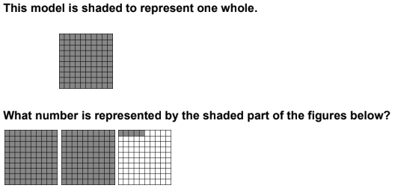
1)

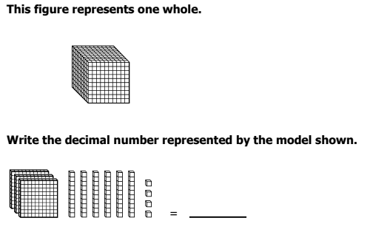
2)

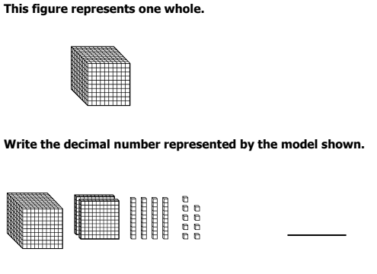
3)

Review HW
TUESDAY
Use number rays to answer the following questions:
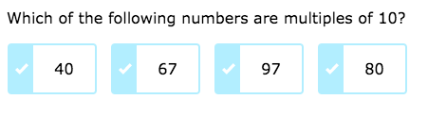
1)

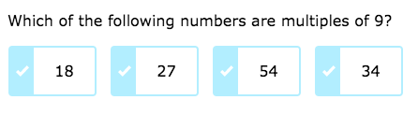
2)

3)

4) Besides 39 and 1, what is one factor of 39?

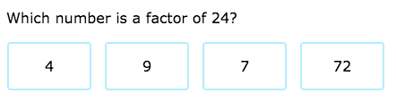
5)

