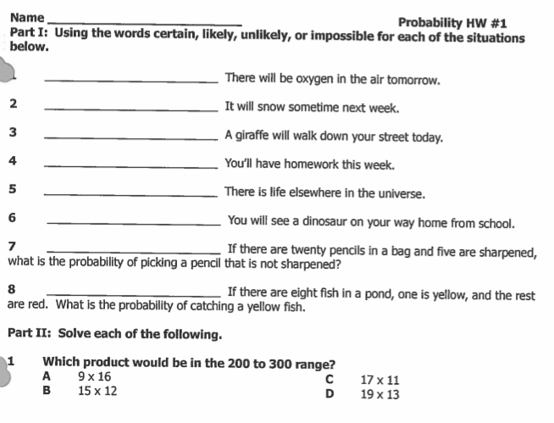

1) What is the likelihood that the spinner will land on RED?

_________________________________ What fraction of the spinner

YELLOW BLUE is RED? _________________

2) What is the likelihood that the spinner will land on BLUE?

BLUE RED __________________________________

What fraction of the spinner is BLUE? _________________
YELLOW
3) What is the likelihood that the spinner will land on YELLOW?

___________________________________ What fraction of the spinner is

YELLOW? ___________________

PART III: Use the probability vocabulary words from part I, and the spinner below, to answer the following questions.

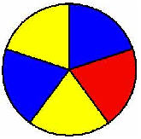

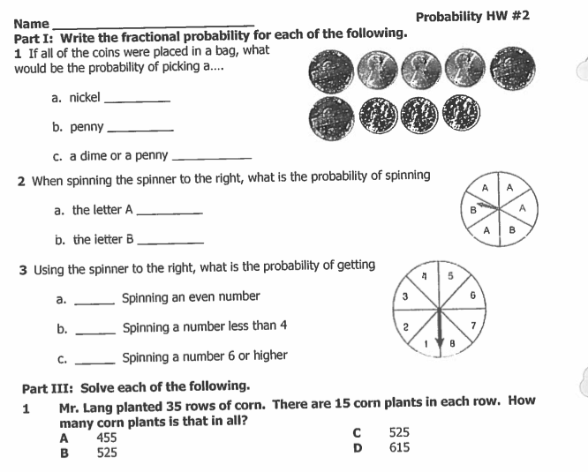

PART IV: Would it be fair if I was playing a game with my friend and we had different spinners like the ones shown below? Why or why not? Explain below.

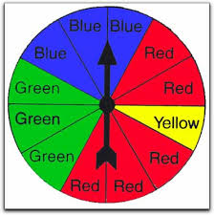
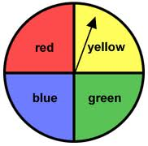

Player 1’s spinner Player 2’s spinner
____________________________________________________________________________________________________________
________________________________________________________________________________________________________________________________________________________________________________________________________________________

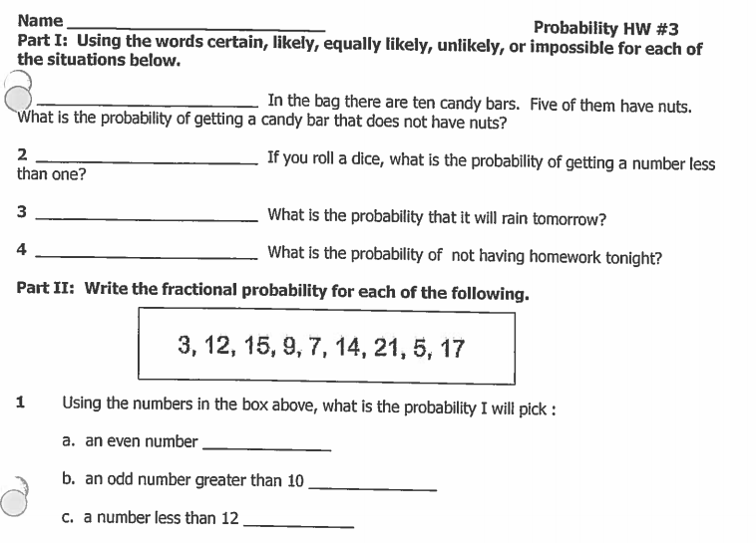

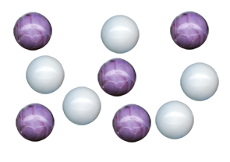
2 If the following marbles were in a baggie and you pulled one out without looking, what is the probability that you would pull out:

a) light marble = _________________

b) dark marble = _________________

c) a striped marble = ______________

d) a round marble = _______________

Please place the fractions on the number line (hint: place 0 and 1 first!)

THURSDAY PROBABILITY HW #4
Name: _____________________________________________

PART I: Using impossible, unlikely, equally likely, likely, and certain answer the following questions.
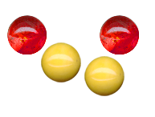
1) If I randomly chose a marble, what is the
chance that the marble will be light colored? _______________________________________________________

2) What is the chance that I will choose a broken marble? _______________________________________________________

3) What is the chance that the spinner will land on the dark area? ___________________________________________

4) What is the chance that the spinner will land on the light area? ____________________________________________

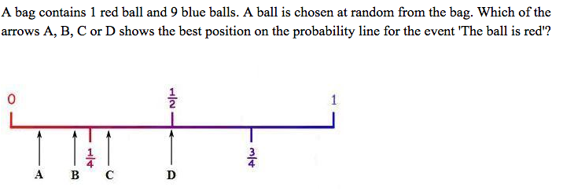
PART II: Use the number line to answer the following question.

PART III: Solve the following multiplication problems.

6) 73 7) 12 8) 55 9) 12 10) 6x7=
x 4 x 35 x 41 x 8

