Name _________________________________
MONDAY – Third Grade Review
Part I: Write each of the following in standard form.

1. Forty two thousand, eleven _________________________

2. Three hundred five thousand, eight hundred seventy six

_____________________________

3. Six hundred twenty thousand, five hundred ten

_____________________________

4. Seven hundred fifty thousand, three hundred seventy

_____________________________

Part II: Identify the place value for each digit in the numbers below.
724,916 402,183
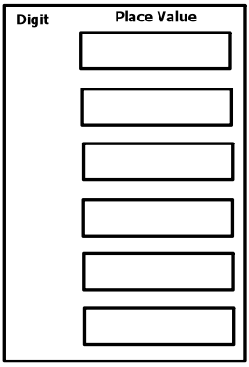
4
2

9
1

2

7

8
1

4

3

0
6

www.forrestmath.weebly.com
Place Value HW
TUESDAY
Part I: Draw and label a place value chart. Be sure to include hundred thousands, tens, thousands, ones, millions, ten thousands, and hundreds.

Part II: Label the place of each digit in the following numbers.

5 7 1, 9 0 2

2, 4 3 8, 0 0 3

6 7, 9 1 2

1, 3 3 6

7, 0 1 0, 3 6 8

WEDNESDAY
Part I: Write the following numbers in both word and expanded form.

Ex) 546 | Five hundred forty-six | 500+40+6
2,671
1, 358, 002
40, 824
734,290

Part II: Write the following standard form numbers in written form.

5) 38,944 ___________________________________________
________________________________________________________________________________________________________

6) 3,709,313 ________________________________________
________________________________________________________________________________________________________

7) 843,620 __________________________________________
________________________________________________________________________________________________________________________________________________________

www.forrestmath.weebly.com
THURSDAY
Part I: use the letters to match the standard form with the correct word or expanded form.
______ 55,890 A) 4,000+800+30+4

______ 3,400,757 B) Nine hundred ten thousand, four hundred eight-two

______ 910,482 C) 50,000+5,000+800+90

______ 4,834 D) Three million, four hundred thousand, seven hundred fifty-seven

______ 3, 004, 831 E) Three million, four thousand, eight hundred thirty-one

Part II: Write the place and value of the underlined digit.
 | Place | Value
Ex) 547 | Hundreds | 40
2,671
1, 358, 002
40, 824
734,290

