Name _________________________________
MONDAY
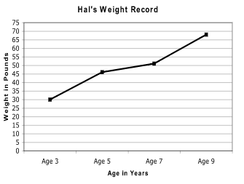
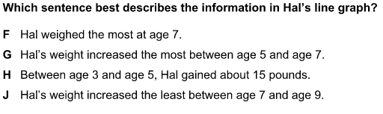

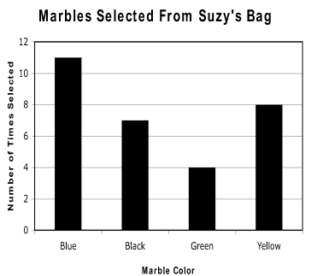
2) Which marble was selected less than 5 times? _________

3) What is the scale counting by? _________

4) A blue marble was selected four less times than a black marble?
true or false
Patterns HW
TUESDAY
1. Label the pattern and then tell me what the 12th shape would be:
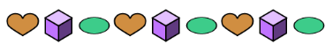

2. Label the pattern and then tell me what the missing numbers would be:
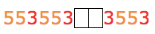

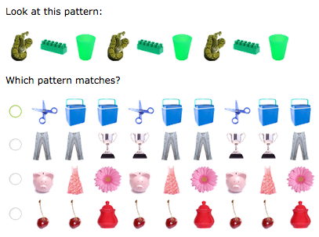
3.

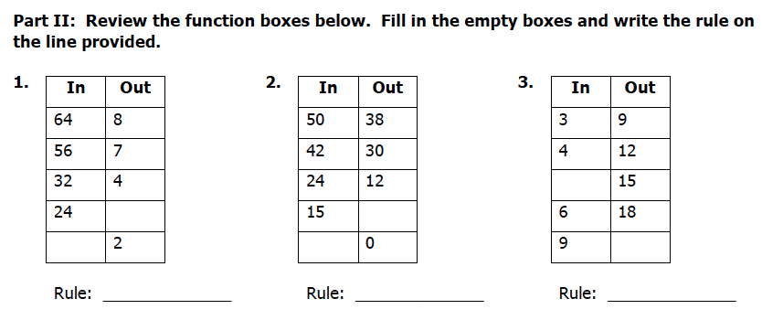

www.forrestmath.weebly.com
WEDNESDAY
Directions: label the pattern and then identify the next two figures.
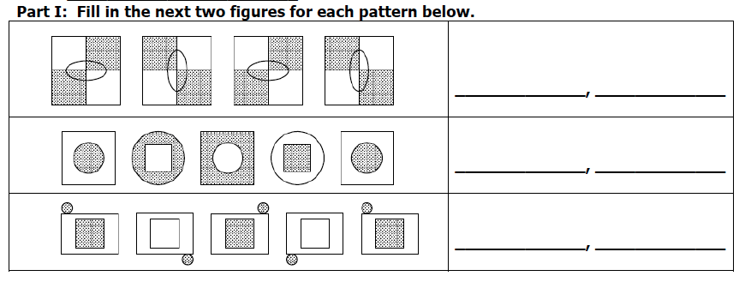

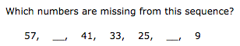
2.)

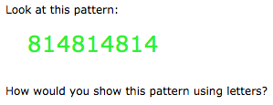

3)

4) Which numbers are missing from this sequence?

26, ______, 20, 17, _______, 11, 8

Part II: Review
Answer the following computation problems (show work)

1) 45.9 + +3.22 2) 1, 8 9 . 0
- 6 5 . 2

THURSDAY
Part I: Function Tables
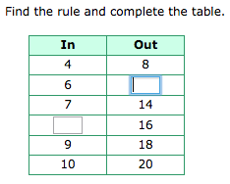
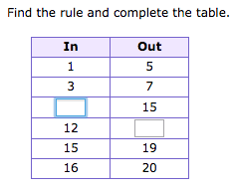
1. 2.

Part II: Extending Growing Patterns – Draw the figure that comes next…
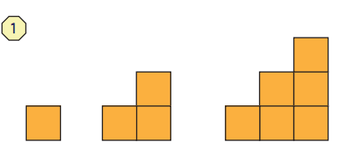

________________________
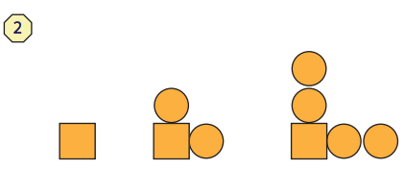

________________________

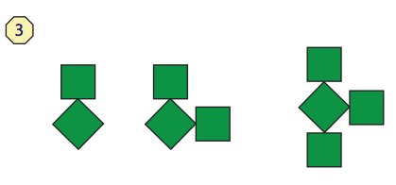

_________________________
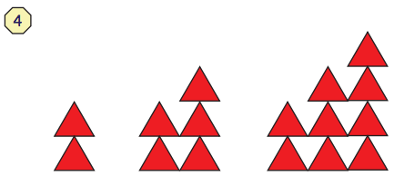

_________________________
www.forrestmath.weebly.com

