Name _________________________________
TUESDAY
In your own words, explain what the least common multiple (LCM) and how to find it: _______________
__________________________________________
__________________________________________

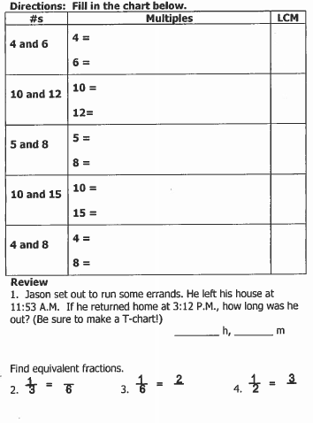

1. Daniel’s school held a food drive. Daniel was given the task of putting 39 canned goods in 5 baskets. How many canned goods did Daniel’s school collect in all?
________

2. A party planner put 4 plates on each table at Monique’s birthday party. There are 64 tables set up at the party. How many people did the party planner expect to be at the party?

A) 60 B) 68 C) 246 D) 256

LCM and GCF HW
WEDNESDAY
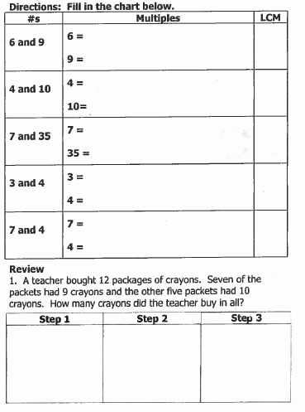

www.forrestmath.weebly.com

THURSDAY

In your own words, explain what greatest common factor (GCF) is and how to find it: __________________________________________
__________________________________________
__________________________________________

