Name _________________________________
MONDAY
In your own words, explain what the least common multiple (LCM) and how to find it: _______________
__________________________________________
__________________________________________
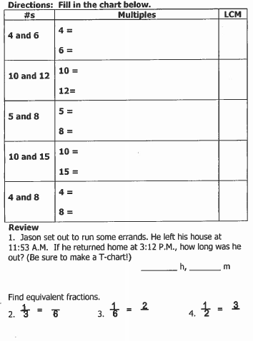

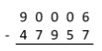
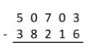
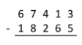

www.forrestmath.weebly.com
LCM and GCF HW
TUESDAY
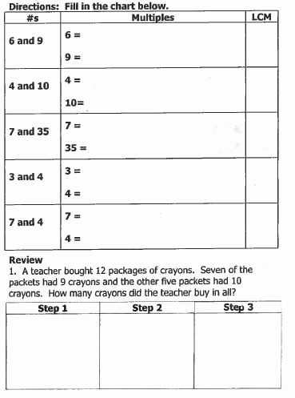

www.forrestmath.weebly.com
WEDNESDAY
In your own words, explain what greatest common factor (GCF) is and how to find it: __________________________________________
__________________________________________
__________________________________________

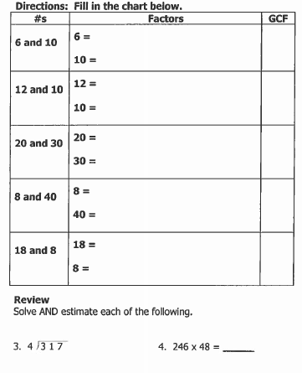

THURSDAY
