Name _______________________________________
MONDAY
Part I: Fill in the chart with the missing information.
Name | Definition | Picture
 | A straight path that is endless
Line segment

 | An exact position in space
Ray

 | Made up of two rays that meet at a vertex

Review
1. Round the following to the nearest hundred thousand and nearest ten thousand.
Number | Nearest  Hundred Thousand | Nearest  Ten Thousand
748,527

2. 74 x 58 = ________ 3. 64 x 6 = ________

4. Phenique collects baseball cards. He had 127 in his collection. He spilled juice on 48 of them and had to throw them away. He received 65 more from his grandfather. How many baseball cards does Phenique have in his collection now?

Geometric Figures HW
TUESDAY
Part II: Draw each of the following figures.
Point | Ray | Line
Line Segment | Angle

Write which of the following is being described below.

_________________________ part of a line with two endpoints

_________________________ a collection of points that extends forever in both directions.

Review
In | Out
4 | 10
6 | 12
9
 | 14
12

In | Out
64 | 8
56 | 7
48
 | 5
32

In | Out
2 | 6
3 | 9
4
 | 15
6

1. 2. 3.

Rule: _______ Rule: _______ Rule: _______

4. Ian and Daniyah were playing a math game. Ian scored 48 points during game one and 56 points during game two. Daniyah scored 61 points during game one and 27 points during game two. How many more total points did Ian score than Daniyah?

WEDNESDAY
Part II: Label each of the following as intersecting, parallel, or perpendicular.
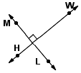
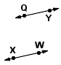
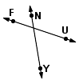
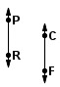
1. 2. 3. 4.

_________ __________ _________ ________

Use the grid below to answer the following questions.
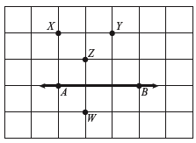
Points A, B, X, Y, Z, and W, and line AB are shown on the grid below.

1. What are two points shown
on the grid that can be connected to form a line segment perpendicular to line AB?

2. What are two points shown
on the grid that can be connected
to form a line segment parallel to
line AB?

Review
1. The difference of 3,512 and 7,082 can best be described as
A close to 1,000 C close to 5,000
B close to 3,000 D close to 7,000

2. Circle all of the following that are true.

8 x 4 = 20 + 12 15 x 2 = 30 ~ 2

24 + 6 = 3 x 10 12 ~ 4 = 12 - 3

16 ~ 4 = 4 + 4 25 + 10 = 7 x 5
THURSDAY
Part I: Use the map below to answer the following questions.
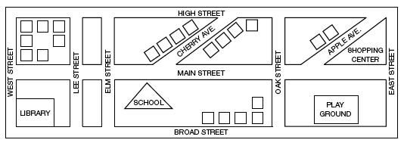

1. Which streets are parallel to Oak Street?

____________________________________________________

2. Which street is parallel to Apple Avenue? ________________

3. Elm Street is perpendicular to which streets?

____________________________________________________

4. Which building marks the point where Broad Street and West Street intersect?

____________________________________________________

Review
5. Mrs. Boone’s class has a goal of raising 1,500 dollars for this year’s PTA fundraiser. In week one, students brought in 368 dollars. In week two, students brought in 497dollars. Exactly how much more money must Mrs. Boone’s class raise to reach its goal? (2 steps!)

6. 3 t 8 7 7. 6 t 4 6 9

