Name ____________________________________________________________
MONDAY
Part I: Fill in the blank with a number to make a true statement.
1. 9 x 8 = 60 + ________ 2. 63 ÷ 7 = _______ x 1

3. 6 x ______ = 9 x 2 4. 8 x ______ = 6 x 4
5. (96 + 45) + 33 = 96 + (45 + _______)

Part II: Draw a line from the expression on the left to its’ equivalent expression on the right.

56 ÷ 7 50 + 50

4 x 3 15 + 10

25 x 4 2 x 6

5 x 5 4 x 2

REVIEW
Part III: Solve each of the following.

1. 8, 5 2 1 2. 5, 1 4 7
+ 5, 3 6 7 - 3, 1 2 8

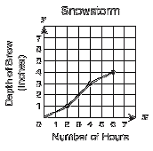
1. How many inches of snow fell after 2 hours? ____________

2. How many inches of snow fell after 6 hours? ___________

3. How many more inches of snow fell after 6 hours than 2 hours? ____________

Equalities HW
TUESDAY
Part I: Fill in the blank with a number to make a true statement.

1. 25 x 5 = 50 + _______ 2. 50 x 6 = 150 + _______

3. 83 + 42 = _______ + 83 4. _______ x 8 = 4 x 4

5. 7 x ( 8 x 3) = (7 x _______) x 3

Part II: Shade each of the following that shows the correct use of the associative property.

(4 + 8) + 2 = 4 + (8 + 2) 2 x (5 x 7) = (2 x 5) x 7

4 + (8 x 3) = (4 + 8) x 3 (7 + 4) + 5 = 7 + (4 + 5)

Part III: Solve each of the following

1. 9 4 2. 9, 5 4 3
x 7 - 9, 0 2 4

REVIEW
The stadium has a total of 5,683 seats. There were 2,490 people that attended the last game. How many seats were empty?

There are two towns in the state of Virginia. The town of Woodburn has a population of 8,097 and the town of Peltin has a population of 1,648. How much greater is the population of Woodburn than Peltin?

www.forrestmath.weebly.com
WEDNESDAY
Part I: Shade each of the following that shows the correct use of the associative property.

(4 x 6) x 3 = 4 x (6 x 3) (3 x 4) x 5 = 3 x (4 x 5)

3 + (7 + 11) = 3 + (11 + 7) ( 4 + 8) + 2 = (4 + 2) + 8

REVIEW
Part II: Solve the following

In 2013 three hundred forty-one students purchased a Forrest yearbook. In 2014 two-hundred ninety students bought one. What is the difference between yearbook sales in 2013 and 2014?

___________________

Part III: Use the line graph below to answer the following questions.
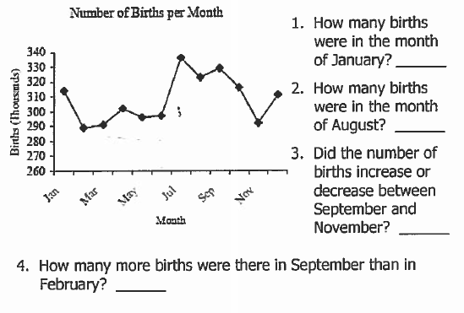

THURSDAY
Part I: Use the balance to answer the following questions.
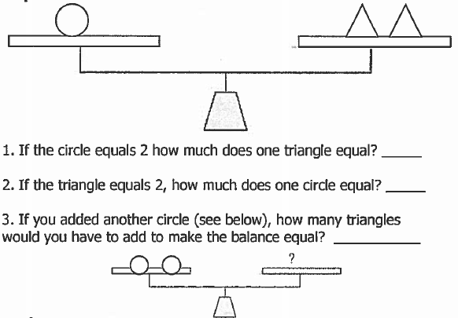

Part II: Solve the following

1. Kiori took her allowance of $20.00 to the store. She wanted to purchase earrings for $2.59, a shirt for $11.99, and a necklace for $6.25. Will she have enough money to pay for those items?
Explain why or why not: _______________________________________________
________________________________________________________________________________________________________________________________________________________

Part III: When rounded to the nearest thousand, which of the following would NOT round to 6,000?

6,451 6,601 5,953

5,417 6,132 6,451
www.forrestmath.weebly.com

