Name ____________________________________________________________
MONDAY
Part I: Fill in the blank with a number to make a true statement.
1. 9 x 8 = 60 + ________ 2. 63 ÷ 7 = _______ x 1

3. 6 x ______ = 9 x 2 4. 8 x ______ = 6 x 4
5. (96 + 45) + 33 = 96 + (45 + _______)

Part II: Draw a line from the expression on the left to its’ equivalent expression on the right.

56 ÷ 7 50 + 50

4 x 3 15 + 10

25 x 4 2 x 6

5 x 5 4 x 2

Part III: Use the balance to answer the following questions.

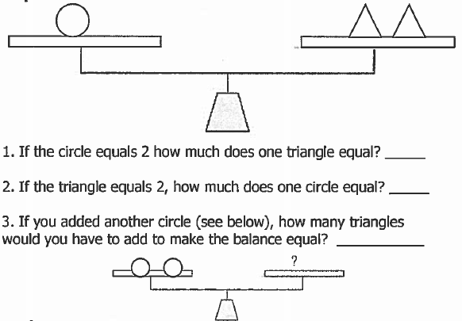
Equality/Multiplication HW
TUESDAY
Part I: Fill in the blank with a number to make a true statement.

1. 25 x 5 = 50 + _______ 2. 50 x 6 = 150 + _______

3. 83 + 42 = _______ + 83 4. _______ x 8 = 4 x 4

5. 7 x ( 8 x 3) = (7 x _______) x 3

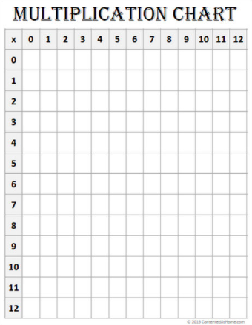
Complete the following multiplication chart:

www.forrestmath.weebly.com
WEDNESDAY
Complete the following basic multiplication facts as quickly as you can.
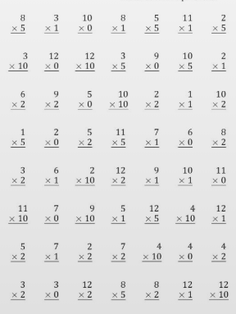

www.forrestmath.weebly.com

THURSDAY
Complete the following basic facts as quickly as you can.
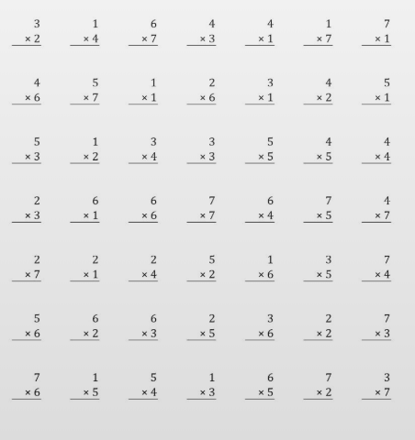

3rd Grade Review

1) 49 2) 33 3) 71
x 2 x 4 x 3

**Practice your facts at home by signing up for a free account at www.xtramath.org **

