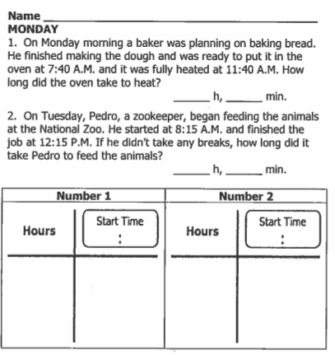

Part II: Draw the big “G” in the space provided below.

www.forrestmath.weebly.com
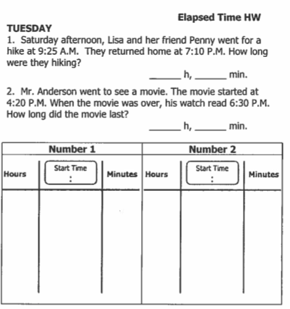

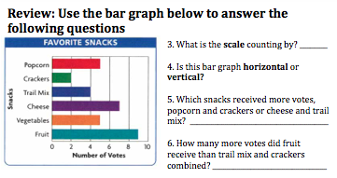

WEDNESDAY
1. Harper fell asleep at 7:45pm. She was asleep for seven hours and twenty minutes before she was woken up by a bad dream . What time did Harper wake up in the middle of the night?
2. Fourth graders began taking their math SOL at 8:30am. If Mrs. Townsend announced that testing was over after 3 hours and 21 minutes, what time was testing completed?
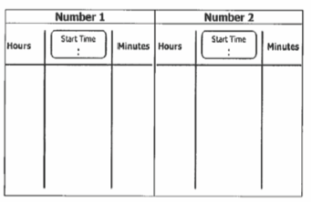

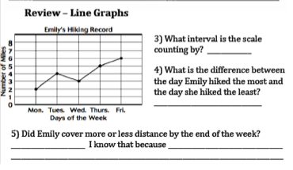
THURSDAY
1. Busch Gardens closes at 10:00pm. If it was open for ten hours and thirty minutes, what time did Busch Gardens open?

2. Kevin Hart crossed the finish line of the New York City marathon at 1:38pm. It took him 4 hours and 5 minutes to run the 26.2 miles. What time did Kevin Hart cross the starting line?

Review
