Name _________________________________
MONDAY

1. Saturday afternoon, Lisa and her friend Penny went for a hike at 9:25 am. They returned home at 7:10pm. How long were they out hiking?
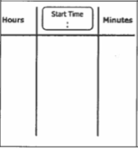

2. Mr. Anderson went to see a movie. The movie started at 4:20pm. When the movie was over, he checked his watch and it said 6:30pm. How long was the movie?

Elapsed Time HW
TUESDSAY
Directions. Read and find one of the following: start time, end time, or elapsed time. Be sure to make a chart to organize your thinking.

1. Jason had to run some errands, which took him five hours and thirty-five minutes to complete. If he returned home at 3:05pm, what time did he get started?

_______________

2. Cassie is making a cheesecake. She got started on it at 1:26pm. Overall, it took her 2 hours and 40 minutes to complete including bake time. What time was she finished making the cheesecake?

_______________

3. Gus and Phillip chartered a fishing boat to go deep-sea fishing. They left the marina at 5:45am. If they returned to the dock at 3:11pm, how long were they out fishing?

_______________

www.forrestmath.weebly.com

WEDNESDAY
Use the chart below to answer the following questions

Movie | Running Time
Small Foot | 1 hr. 36 min.
Venom | 1 hr. 52 min.
Goosebumps 2 | 1 hr. 30 min.

1) Harper really wanted to see Goosebumps 2. I only had from 1:47pm until 3:05pm to see it. Would we have enough time? Tell me how you know.

____________________________________________________

2) The 5th grade teachers all went to see Venom this past weekend. The movie let out at 9:30pm. What time did it start?

_________________

3) There’s a drive-in theater in Mrs. Townsend’s hometown. It shows two movies in one night back-to-back! If Mrs. Townsend went to see both Goosebumps and Small Foot at 8:20pm, what time would the second movie be over?

_______________

THURSDAY
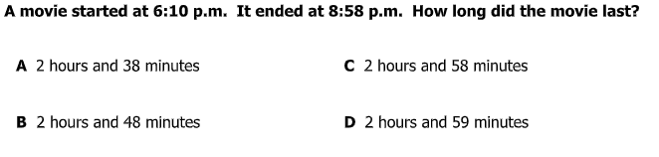
1)

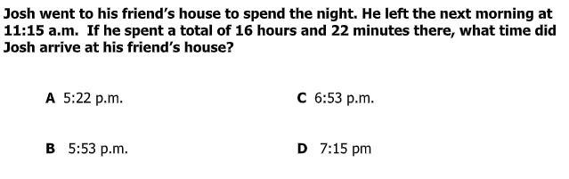
2)

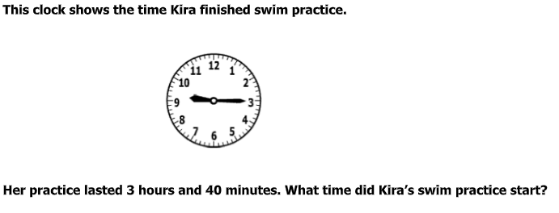
3)

4)

www.forrestmath.weebly.com

