Name ________________________________
MONDAY
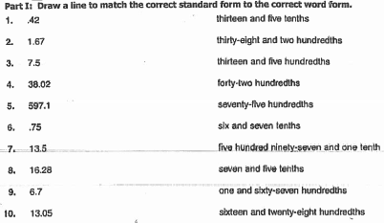

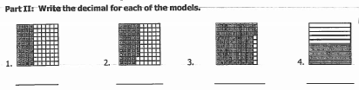

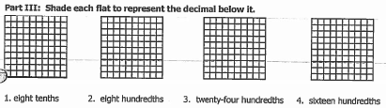

Part IV: Label the following numbers with the correct place values

32.013 1.54 0.3

Decimal PV, Comparing, and Ordering HW
TUESDAY – Review comparing and ordering whole numbers.

PART I: Stack and compare the following numbers using the symbols (>, <, =).

1) 3,824 ____ 3,428 2) 3,324 ____ 3,248

3) 3,824 ____ 3,824 4) 45,983 ____ 54,983

5) 54,389 ____ 45, 538 6) 809,661 _____ 809,662

PART II: Use numbers and symbols to write the statements below

1. two thousand, six hundred thirty-four is greater than two thousand, four hundred sixty-three ___________________________________

2. six thousand, two hundred sixty is less than six thousand, six hundred twenty ___________________________________

3. six hundred four thousand, three hundred twenty is less than six hundred forty thousand, three hundred twenty _____________________

Part III: Put the following numbers in order.

From greatest to least: 63,289; 36,571; 63,892; 63,280; 60,446

____________________________________________________________________________

From least to greatest: 1,385; 1,528; 1,296; 1,509; 1,032

____________________________________________________________________________

www.forrestmath.weebly.com
WEDNESDAY
1. Explain the strategy you would use to compare 13.4 and 13.04
____________________________________________________________________________________________________________________________________________________________
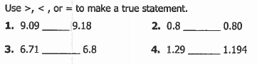

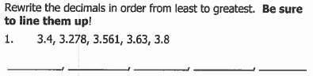

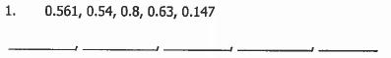

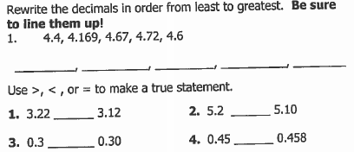

THURSDAY
Part I: Fill in the chart below
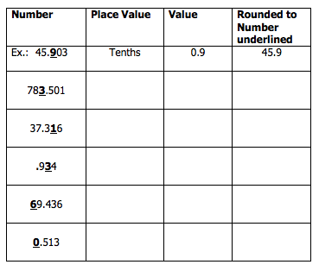
Part II: Round the following decimals to the specified place value.

Round each of the following decimals to the nearest tenth.

1. 2.36 ___________ 2. 45.19 ____________
3. 5.321 ___________

Round each of the following to the nearest whole number.

1. 23.14 __________ 2. 3.962 ____________
3. 68.49 ___________

