Name _________________________________
MONDAY
Part I:
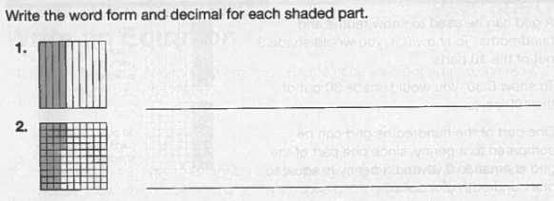

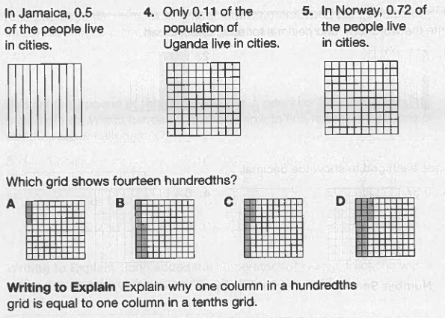
Part II: For numbers 3-5, shade the given decimal
3.

6.

7.

____________________________________________________________________________________________________________________________________

www.forrestmath.weebly.com
Decimal Review HW
TUESDAY
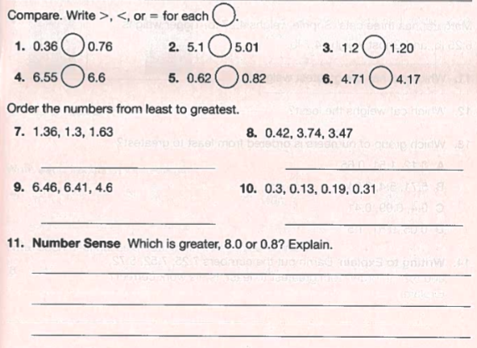

Part II: Use the information below to answer #11-12
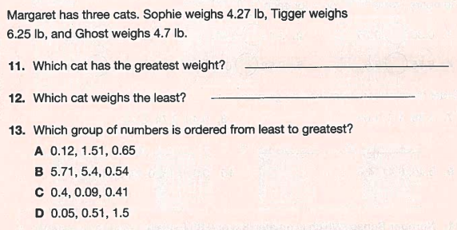

WEDNESDAY
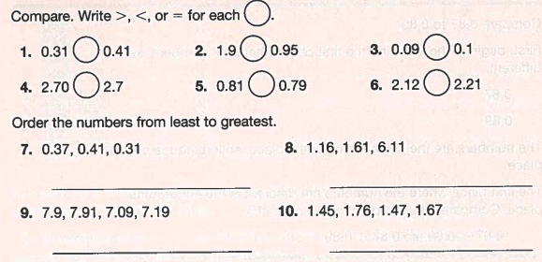
Part I: Compare or order the following decimals.

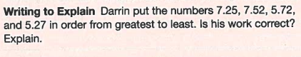

____________________________________________________________________________________________________________________________________

Part II: Round the following decimals to the place value mentioned.

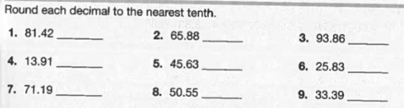

www.forrestmath.weebly.com
THURSDAY
Mixed Review



