Name __________________________________________________________
MONDAY

PART I: Stack and compare the following numbers using the symbols (>, <, =).

1) 3,824 ____ 3,428 2) 3,324 ____ 3,248

3) 3,824 ____ 3,824 4) 45,983 ____ 54,983

5) 54,389 ____ 45, 538 6) 809,661 _____ 809,662

PART II: Use numbers and symbols to write the statements below

1. two thousand, six hundred thirty-four is greater than two thousand, four hundred sixty-three ___________________________________

2. six thousand, two hundred sixty is less than six thousand, six hundred twenty ___________________________________

3. six hundred four thousand, three hundred twenty is less than six hundred forty thousand, three hundred twenty _____________________

Part III: Put the following numbers in order.

From greatest to least: 63,289; 36,571; 63,892; 63,280; 60,446

____________________________________________________________________________

From least to greatest: 1,385; 1,528; 1,296; 1,509; 1,032

____________________________________________________________________________

www.forrestmath.weebly.com
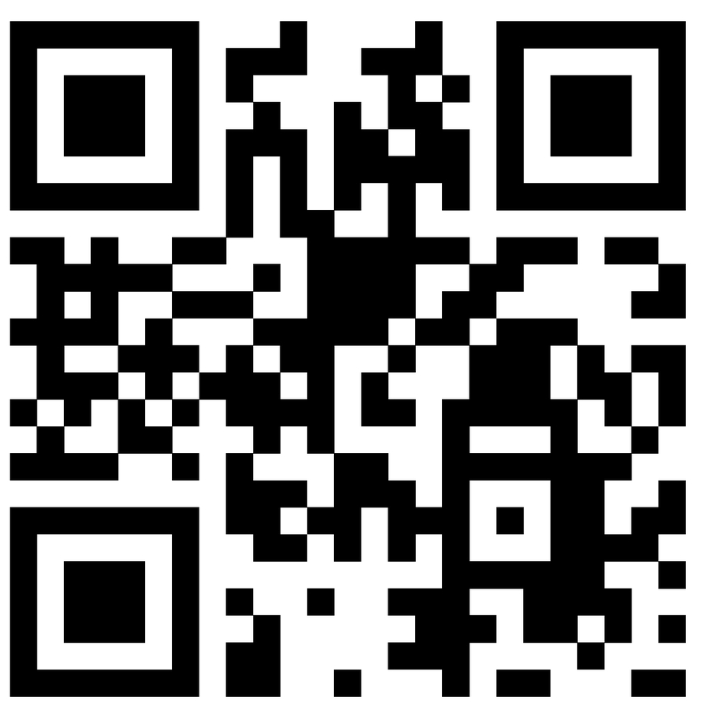
Decimal Place Value
TUESDAY
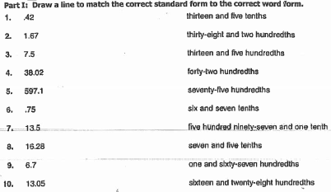

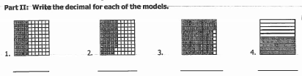

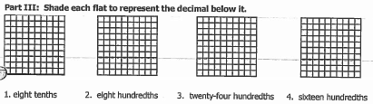

Part IV: Label the following numbers with the correct place values

32.013 1.54 0.3

WEDNESDAY
Part I: Choose the correct standard form for each of the following.

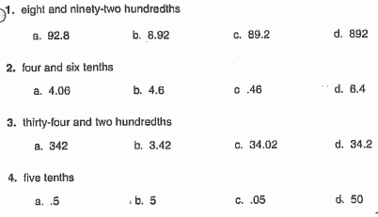

Part II: Round each of the following to the nearest ten thousand.
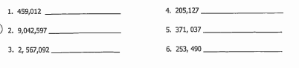

REVIEW
Part III: Fill in the blank using >, < or = to make a true
statement.

1. 5,607,812 ______ 5,760,821 2. 901,234 ______ 9,012,340

3. 9 x 8 _______ 8 x 8 4. 8,901,345 ______ 8,901,534
5. 25 x 3 _______ 8 x 7

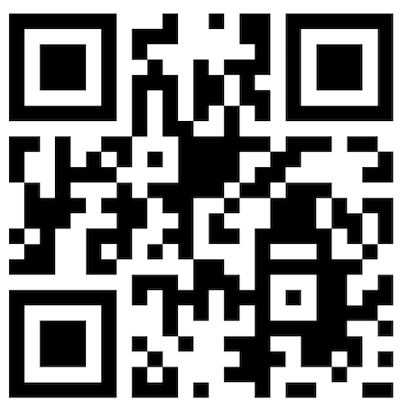
THURSDAY

