Name _________________________________
MONDAY
Use >, <, or = to compare the following decimals.

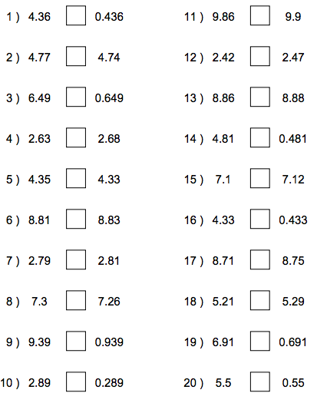

www.forrestmath.weebly.com
1st Quarter Review HW
TUESDAY
Order the following decimals from least to greatest.

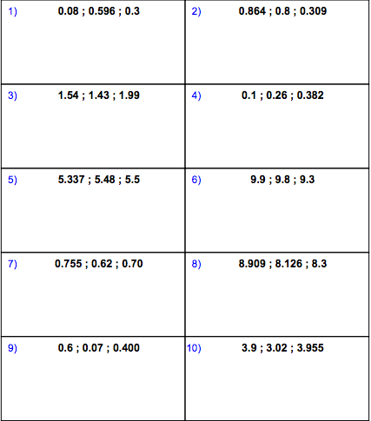

WEDNESDAY
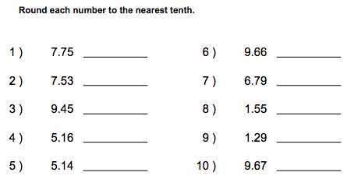
Round each decimal to the directed place.

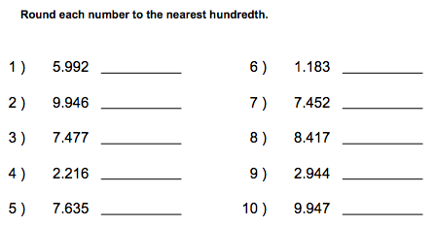

Round each number to the nearest whole number
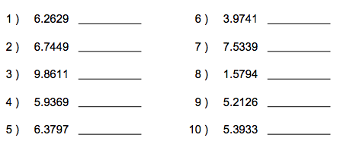

THURSDAY
Complete the multiplication chart below.

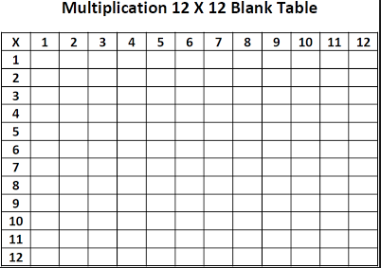

Use the multiplication chart to answer the following:

