WEDNESDAY

Explain the strategy you would use to compare 13.4 and 13.04
____________________________________________________________________________________________________________________________________________________________
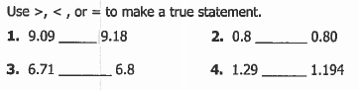

Circle the number with the greatest value

9.09 6.71 0.8 9.19 6.8

Circle the number with the least value

9.09 6.71 0.8 9.19 6.8

Maggie has three cats. Abe weighs 4.27 lbs, Bob weighs 6.25 lbs, and Cal weighs 4.7 lbs.

Which cat has the greatest weight? _____________

Which cat has the least weight? _____________

www.forrestmath.weebly.com

Compare/Order Decimals HW
THURSDAY
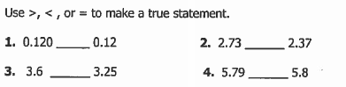

5. 3.22 _____ 3.12 6. 5.2 ____ 5.10

7. 0.3 ____ 0.30 8. 0.45 ____ 0.458

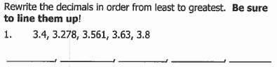

Rewrite the decimals in order from greatest to least. Be sure to line them up!

4.4, 4.169, 4.67, 4.72

______ ______ ______ ______

Which group of numbers is ordered from least to greatest?

A) 0.12, 1.51, 0.65

B) 5.71, 5.4, 0.54

C) 0.4, 0.09, 0.41

D) 0.05, 0.51, 1.5
Name __________________________________
MONDAY
Round the following decimals to the nearest whole.

1. 2.36 ___________ 2. 45.19 ____________
3. 5.321 __________ 4. 23.14 __________
5. 3.962 ____________ 6. 68.49 ___________

When rounded to the nearest whole number, which decimals round to 9? Circle all correct answers.

9.6 9.4 8.05 9.69

8.71 9.02 8.45 9.07

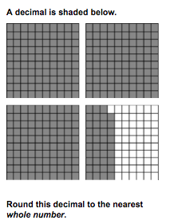
Fill in the blank using >, <, =, and ≠ to make a true statement.

1. 5,607,812 ______ ______ 5,760,821

2. 901,234 ______ ______ 9,012,340

3. 9 x 8 _______ ______ 8 x 8

4. 8,901,345 ______ ______ 8,901,534

5. 25 x 3 _______ ______ 8 x 7

Rounding Decimals HW
TUESDAY
When rounding to the nearest whole, which decimals round to 23?

23.61 23.06 23.79 22.55 23.77 23.84

It is 3.6 miles from Sally’s house to McDonald’s. Estimate the distance from Sally’s house to McDonalds.

A) 3 miles B) 4 miles C) 5 miles D) 6 miles

Round each decimal to the nearest whole number.

1. 25.78 ________ 2. 17.26 ________

3. 4.51 ________ 4. 52.61 ________

5. 73.491 ________ 6. 42.35 ________

7. 27.38 ________ 8. 6.528 ________

