**Name _________________________________**

**MONDAY**

**Directions: Fill in the chart below.**

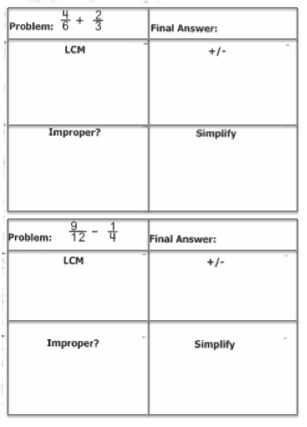

[www.forrestmath.weebly.com](http://www.forrestmath.weebly.com)

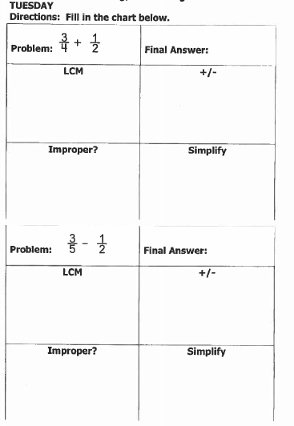**Fraction Word Problems HW**

