Name _________________________________
MONDAY
Convert the following improper fractions into mixed numbers by creating a drawing.

1. 9%

2. 8#

3. 8$

Find the greatest common factor (GCF) for the following numbers.

8
14

GCF = _____

10
20

GCF = _____

6
12
32

GCF = _____

www.forrestmath.weebly.com
Add/Sub Fractions HW #2
TUESDAY
Build on last week’s work. Find LCM, make like denominators, and then decide if the added answer is improper. If it is… change it to a mixed number!
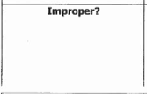
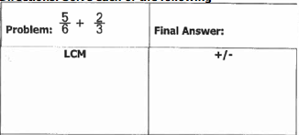

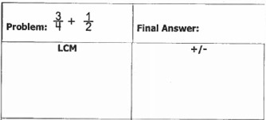

WEDNESDAY
Complete the 4-square! Practice makes perfect. Go through all four steps of adding or subtracting fractions.
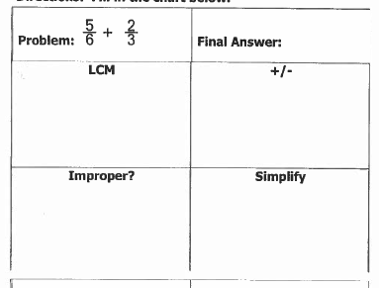

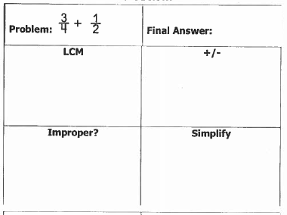

THURSDAY
Subtract the following fractions. Go through all steps.
