**Name _______________________________**

**MONDAY**

**Directions: Solve each of the following**

1. 3^ + 2^ 2. 7! ) - 2! ) 3. 8! @ + 4! @

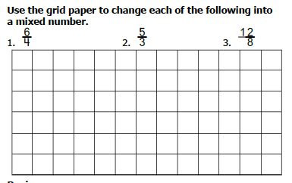



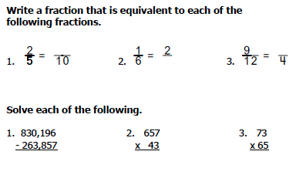

[www.forrestmath.weebly.com](http://www.forrestmath.weebly.com)

**Add/Sub Fractions**

**TUESDAY**

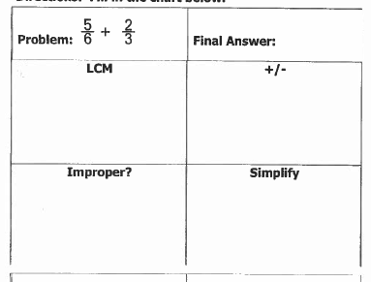**Directions: Solve each of the following**



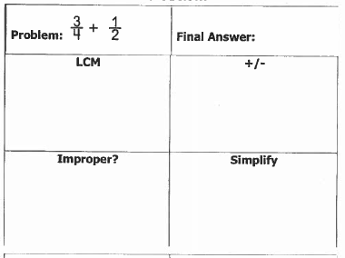

**Wednesday**

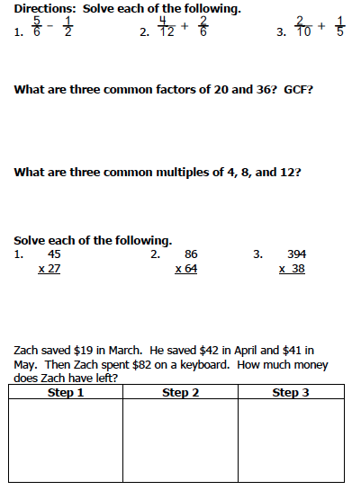**Directions: Solve each of the following**

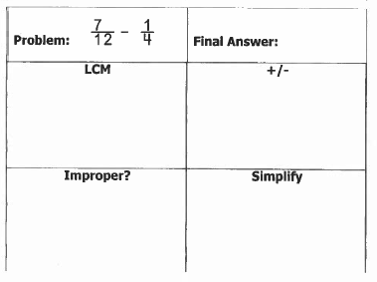

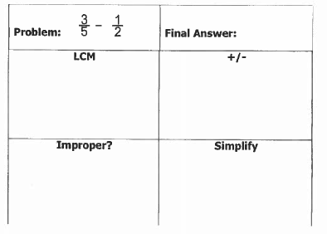

**THURSDAY**



[www.forrestmath.weebly.com](http://www.forrestmath.weebly.com)