Name _________________________________
WEDNESDAY
Solve the following.
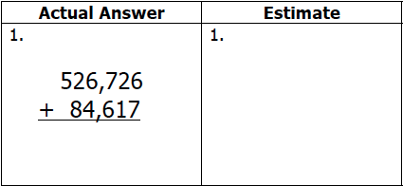
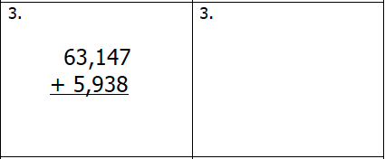

Tourists spent $114,682 during the summer of 2016 and $352,880 during the summer of 2015. Approximately how much money did tourists spend during those two summers?

www.forrestmath.weebly.com
Estimating Sums
Solve the following
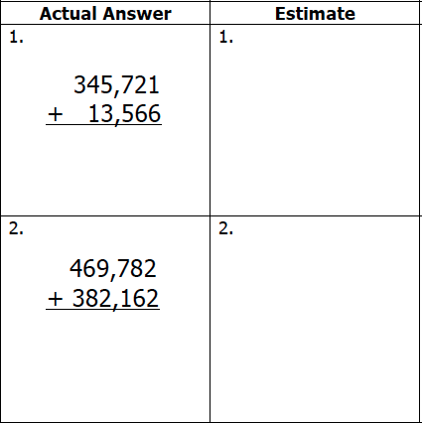

Mrs. Whetsel buys supplies for her classroom each year. Over the past 5 years she has purchased approximately 1,400 pencils. Which of the following could be the number of pencils that she actually purchased?

A) 1,299 B) 4,100

C) 1,328 D) 1,358

Name _________________________________
THURSDAY
Solve the following.

Actual Answer Estimate
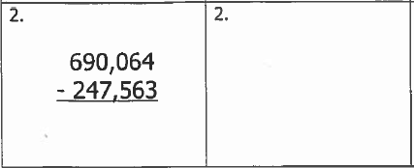
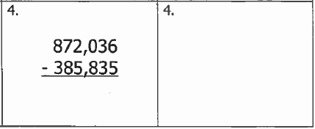

Old McDonald harvested 63,871 pounds of hay. Lightening struck his barn and burned 21,344 pounds of hay. About how much hay is still in Old McDonald’s barn now?

A) 30,000 lbs. A) 40,000 lbs.

C) 50,000 lbs. D) 60,000 lbs.

www.forrestmath.weebly.com
Estimating Differences HW

Solve the following.

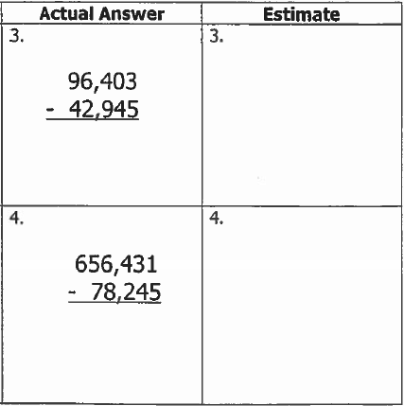

Hurricane Matthew left about 100,000 people without power. Dominion Power has been able to get power back to about 70,000 people since the storm. Which of the following number sentences could be used to determine how many people are still without power?

A) 94,736 – 71,819 B) 101,284 – 64,890

C) 98,010 – 68,722 D) 110,284 – 73,887

