Name _______________________________________
MONDAY

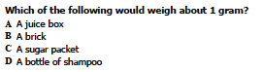

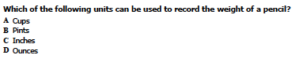

Write a math sentence and solve the problem using an array.

Zack ran 4 miles a day for 13 days straight. How many total miles did he run?

Review:

Write 2 related facts for each of the following:

7 + 2 = 9 | 18 – 6 = 12

www.forrestmath.weebly.com
Measurement HW
TUESDAY

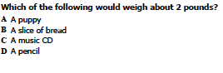

Draw a picture and write a math sentence to go with the problem.
Cai collected 65 marbles and then lost 38. She then got 16 more. How many does she have now?

Which number sentence could be used to find the answer to
9 + 4 = ___

A 15 – 9 = 6 C 5 + 8 = 13
B 4 + 6 = 10 D 13 – 9 = 4

Review

7+ 6 = ____ 14 – 7= ___ 8 + 4 = ___

18-9 = ____ 3 + 4 = ___ ___ = 7 + 3

10 + 0 = ____ 7 – 6 = ____ ___ + 9 = 13

Wednesday:
Use the scale below:
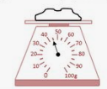

What is the scale counting by? _______

How much does the object weigh? _______

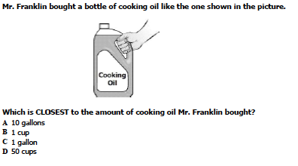
Review:

What is the value of the 5 in 475?

A 5 B 50 C 500

How many tens are in 679?

A) 6 B) 7 C) 9 D) 70
Thursday:

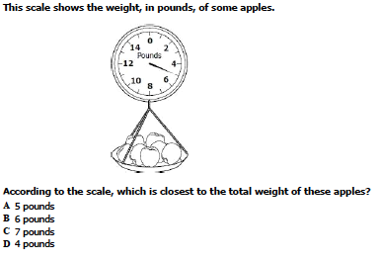

Write 3 related facts for each math sentence.

2 + 6 = 8 | 17 – 9 = 8

Solve: show all work

47 69 76
+26 - 36 - 58

