Name _______________________________________
TUESDAY
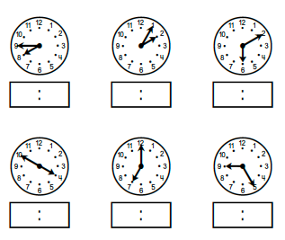
Write the time shown on the clocks below.

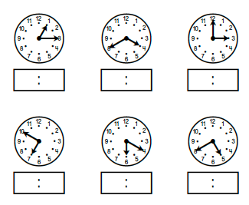

Time HW
WEDNESDAY
1. On Monday morning a baker was planning on baking bread. He finished making the dough and was ready to put it in the oven at 7:40 A.M. and it was fully baked at 11:40 A.M. How long did the bread take to bake?
______ hours

2. On Tuesday, Pedro, a zookeeper, began feeding the animals at the National Zoo. He started at 8:15 A.M. and finished the job at 12:15 P.M. If he didn’t take any breaks, how long did it take Pedro to feed the animals?
______ hours

Number 1 | Number 2
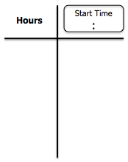

Review
3. Round the following to the nearest hundred and nearest thousand.
Number | Nearest  Hundred | Nearest  Thousand
5,483

4. Marcel went to a concert. There were 8,209 total people at the concert and 3,015 of those people were males. How many people were female?
www.forrestmath.weebly.com Twitter @ForrestMath1406
THURSDAY
1. Saturday afternoon, Lisa and her friend Penny went for a hike at 9:25 A.M. They returned home at 4:25 P.M. How long were they hiking?
______ hours

2. Mr. Anderson went to see a movie. The movie started at 4:30 P.M. When the movie was over, his watch read 6:30 P.M. How long did the movie last?
______ hours

Number 1 | Number 2

Review from 2nd grade
3- 4. Count each collection of coins. Write the value of each collection on the line underneath the collection.
Q dddD
nnppp

Q q nN n ddp

Value: _________ Value: _________

5. The sum of 6,235 + 4,681 is a little more than –
A 10,000 C 14,000
B 12,000 D 16,000

6. Jason set out to run some errands. He left his house at 11:40 A.M. If he returned home at 3:40 P.M., how long was he out?
______ hours
7. Cassandra is making a cheesecake. She puts it in the oven at 1:26 P.M. and doesn’t take it out until 4:26P.M. How long did it take for the cheesecake to cook?
______ hours

Number 1 | Number 2

Review
Fill in the pattern boxes below.
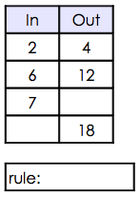
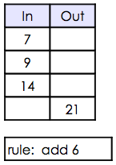
8. 9.

www.forrestmath.weebly.com Twitter @ForrestMath1406

