Name _________________________________
MONDAY

Part I: Use the number lines to help round the following numbers to the nearest TEN.
72 round to _______

39 rounds to ________

65 rounds to ________

14 rounds to ________

Beth read 78 pages in her new book. Round 78
to the nearest ten.

F 50
G 60
H 70
J 80

Rounding HW
TUESDAY

Part I: In your own words, explain how you would round the number 33 to the nearest ten:
________________________________________________________________________________________________________________________________________________________________________________

Part II: Round the following numbers to the nearest TEN

9 rounds to _______ 54 rounds to ________

31 rounds to _______ 98 rounds to ________

75 rounds to ________ 13 rounds to ________

Part III: Circle the numbers that do NOT round to 20 when rounding to the nearest ten.

11 25 23

16 21 14

Beth counted 678 beans in a jar. How many tens
are in 678?

_________
www.forrestmath.weebly.com
WEDNESDAY
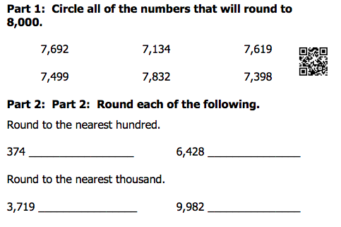

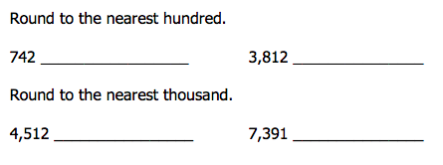

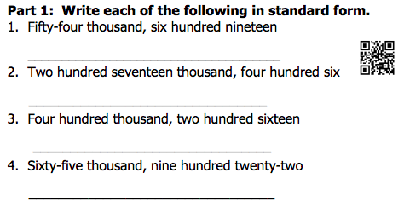

THURSDAY
Part I: Write the place of the underlined digit, then round to that place.
Number | Place | Rounded Number
Example  42 | Tens | 40
96

13

385

456

953

239

Review: Write the following numbers in expanded form.

Ex) 63,082 = 60,000 + 3,000 + 80 + 2

1) 533 = ____________________________________

2) 815 = ____________________________________

3) 8,407 = ___________________________________

4) 5,229 = ___________________________________

5) 29,992 = __________________________________

www.forrestmath.weebly.com

