TUESDAY *Second Grade Review*
Part I: Define

What is a related fact? _________________________________
____________________________________________________

Part II: Write four different related facts using the numbers given.
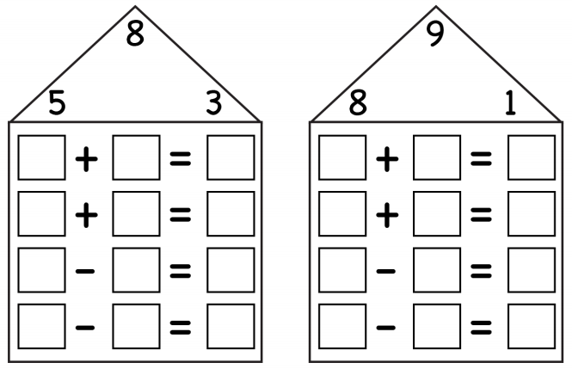
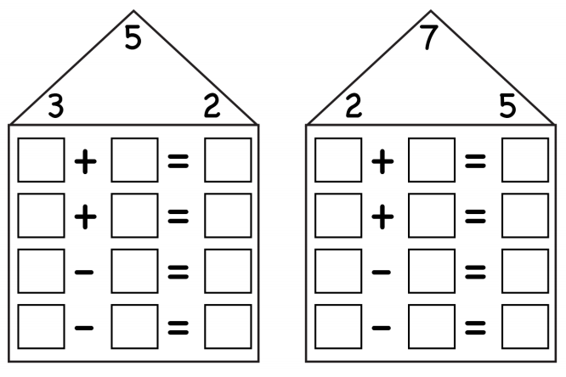

Test Practice Thursday

WEDNESDAY
Part I: Basic addition test practice
1. What number makes this statement TRUE? 9 – ? = 7

A) 2 B) 3 C) 7 D) 16

2. Which number can be placed on the line to make the number sentence TRUE?
4 + ___ = 12

A) 4 B) 6 C) 7 D) 8

3. Which of the following could be solved using this numerical sentence?
16 + 9 = _____

A) Don has 16 small cars. His father gave 9 to his brother. How many cars does Don have now?

B) Don sold 9 of his 16 cars. How many does he have left?

C) Don’s brother has 16 cars. Don has 9 cars. How many cars do Don and his brother have altogether?

D) Don’s uncle gave him 9 cars for his birthday. Don’s dad gave him 6 cars for mowing the lawn. How many cars does Don have altogether?

Part II: Related facts test practice

4. Which fact is a related fact to 8 – 1 = 7?

A) 7 + 2 = 9 C) 9 – 7 = 2

B) 1 + 8 = 9 D) 1 + 7 = 8

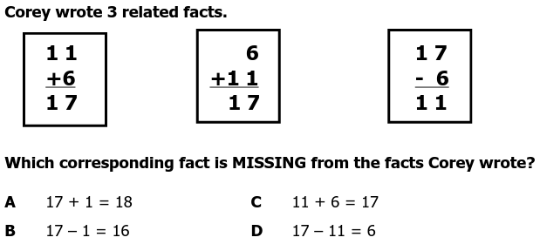
5.

THURSDAY
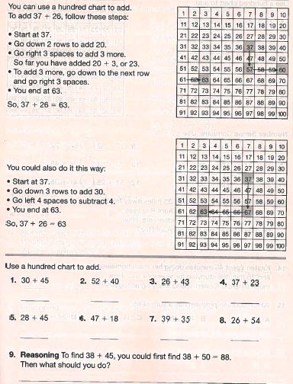

www.forrestmath.weebly.com
100’s chart

