Name _________________________________________________________
MONDAY
Match the probability vocabulary word with its’ correct definition.

An event with the probability of 0. certain
Will not happen.

An event with the probability that is close unlikely
to 1. Has a good chance of happening

An event with the probability close to 0. Impossible
Very low chance of happening.

An outcome with the same probability. Equally likely
50/50 chance of happening.

The chance that an event will happen. Likely

An event with the probability of 1. Probability
100% chance of the event happening.

Using the vocabulary above, determine the probability for the
5) Which color is the spinner MOST LIKELY to land on? And how do you know?

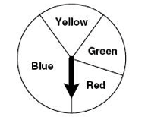

_________________________________________

_________________________________________

following situations. Explain your choice.

7) What is the probability that the sun will rise tomorrow
morning?
____________________________________________________________________________

8) What is the probability that you will need to wear a coat to
school tomorrow?
____________________________________________________________________________

9) What is the probability that they sky will turn purple?
____________________________________________________________________________

10) What is the probability that you will get a good night’s sleep?
____________________________________________________________________________

Probability HW
TUESDAY
Explore probability.

1) What is the probability that a coin will land on heads? ___________

2) Write the fraction that represents the probability that a coin
will land on heads ____________

3) Toss a coin 100 times. Record your tosses with tally marks in
the chart below:
Heads | Tails

4) Was your probability prediction correct? Explain. ________________
____________________________________________________________________________

www.forrestmath.weebly.com

WEDNESDAY
Problem  Abby went to McDonalds and bought a milk shake for $1.85. She gives the clerk $5.00. How much change should she get back? | Draw your answer here using coins and bills. | Show your answer here using subtraction
Problem  Jake gives the cashier $5.00. He purchased a t-shirt for $3.68. How much change will he get back? | Draw your answer here using coins and bills. | Show your answer here using subtraction

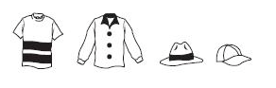

2. Mrs. Taft has these flowers and vases to choose from. How many combinations of flower and vase can Mrs. Taft make?

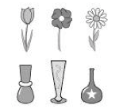

______________________

- Reed has to choose from these hats and shirts
for a costume. How many different combinations of one hat and one shirt can Reed make?

______________________

Look at the tally chart below and answer the following questions:
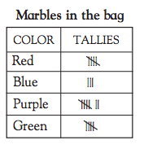
3. What is the probability that you would pick a yellow marble?
__________________________

4. What is the likelihood that you would pull out a red or green marble?

_____________________
THURSDAY
Solve each answer by making the correct change

Tiana went to Sweet Frog for some FroYo. She just couldn’t decide what she wanted so she needs your help. Make a list of all of the possible combinations Tiana could choose from the table below.

Cheesecake FroYo | Graham crumbs
Mint Chocolate FroYo | Gummy Bears
Red Velvet FroYo | Crushed Oreos

