Name _______________________________________
MONDAY

1. What is a polygon? __________________________________
________________________________________________________________________________________________________
Circle the shapes below that ARE polygons
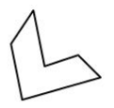
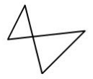
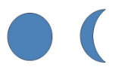

Draw the following plane figures:
Triangle | Rectangle | Square

Describe the following plane figures:

Quadrilateral: _____ sides Octagon: _____ sides

_____ angles _____ angles

Hexagon: _____ sides Decagon: _____ sides

_____ angles _____ angles

Plane and Solid Figures
TUESDAY
Name the following quadrilaterals:
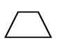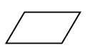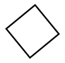
___________ _____________ ___________

Name the following plane figures:
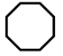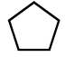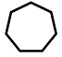
___________ _____________ ___________
Josh folded these six squares to form a solid figure.
What solid figure did he make?

_________________

Match the solid shape with its’ name:

Cube

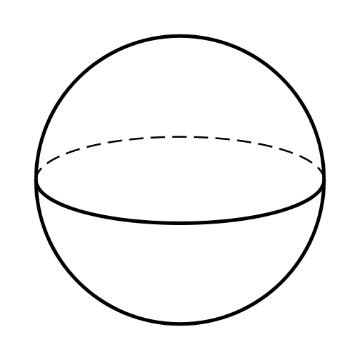
Rectangular Prism

Sphere

WEDNESDAY
What plane shapes make up each solid shape?
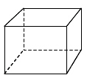
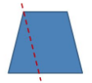
Ex. A cube is made up of 6 squares.

- 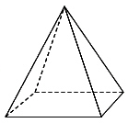 _____________ ________________

2. 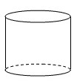 _____________ ________________

3. 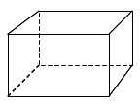 _______________

What solid figures can be made by folding the following?

4. 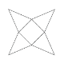 5. 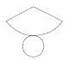 6. 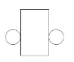
_____________ ______________ ______________

www.forrestmath.weebly.com

THURSDAY
1. If I subdivide the trapezoid below, what smaller shapes do I make?
_____________

_____________

2. If I combine the two shapes below, what larger shape do I make?

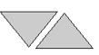 _________________

3. Claire went home and decided to see how many spheres she could find in her house. Circle all of the following that are spheres:

basketball car tire orange

banana baseball marble

4. A cube and a rectangular prism both have-

F 8 faces
G 6 edges
H 8 vertices
J 8 edges

5. What items in your house are shaped like:

rectangular prism: ________________________

cylinder: _____________________________

cube: ______________________________

