**Name _______________________________________**

**MONDAY**

**Part 1: Write each of the following in standard form.**

1. Forty two thousand, eleven _________________________

2. Three hundred five thousand, eight hundred seventy six

_____________________________

3. Six hundred twenty thousand, five hundred ten

_____________________________

4. Seven hundred fifty thousand, three hundred seventy

_____________________________

**Second Grade Review:**

**Part 2: Write the missing number. Then write three related facts.**

|  |  |  |
| --- | --- | --- |
| **8 + 7 = _____** | **14 – 8 = _____** | **12 – 5 = _____** |
| **_____________**  **_____________**  **_____________** | **______________**  **______________**  **______________** | **______________**  **______________**  **______________** |

**Solve:**

**8.** 5 7  **9.** 6 4 **10.** 8 5

+ 3 8 + 1 3 - 4 8

[www.forrestmath.weebly.com](http://www.forrestmath.weebly.com)

**Place Value HW**

**TUESDAY**

**Part 1: Write each of the following in standard form.**

1. Seventy nine thousand, nine hundred ninety-three

_____________________________________

2. Five hundred fifty thousand, two hundred seven

________________________________

3. Three hundred fifty thousand, seven hundred sixty eight

________________________________

4. Forty two thousand, one hundred eleven

_________________________________

**Review**

**Part 2: Use the graph below to answer the following questions.**

**1.** What is the total number of BMX bikes and Mountain bikes

sold? ____________________________

**2.** How many more Children’s bikes were sold than Road bikes?

____________________________

**3.** What is the total number of bikes sold for the whole week?

**________________________**

**WEDNESDAY**

**Write the word form of each word then write the value of the underlined digit**

|  |  |  |
| --- | --- | --- |
| **Number** | **Word Form** | **Value of underlined digit** |
| **Example:**  4,022 | four thousand, twenty-two | 4,000 |
| 345,831 |  |  |
| 815,306 |  |  |
| 924,856 |  |  |
| 763,210 |  |  |

**Preview**

Alexsia had 24 cupcakes to share with her classmates. If there are 8 girls and 9 boys in her class, how many cupcakes will be left over?

Mrs. Crump baked cookies over the weekend. She had to bake 80 cookies total for her church picnic. If she baked 37 chocolate chip and 24 peanut butter cookies on Friday, how many does she have left to bake on Saturday?

[www.forrestmath.weebly.com](http://www.forrestmath.weebly.com)

**THURSDAY**

**Identify the place value for each digit in the numbers below.**

724,916 402,183

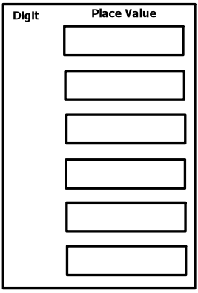

**4**

**2**

**9**

**1**

**2**

**7**

**8**

**1**

**4**

**3**

**0**

**6**

**Review: Write true or false for each of the statements.**

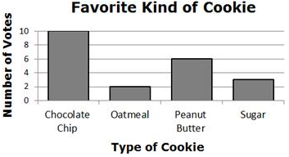

**_____** More sugar cookies were sold than oatmeal.

______ The total number of chocolate chip cookies is less than the total number of oatmeal and peanut butter cookies combined.