Name _______________________________________
WEDNESDAY
Part 1: Write the rule for each pattern below. Then fill in the next two numbers.

1. 23, 26, 29, 32, _______, _______ Rule: _____________

2. 54, 46, 38, 30, _______, _______ Rule: _____________

3. 27, 32, 37, 42, _______, _______ Rule: _____________

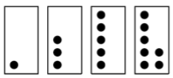
4.

_________, __________

Circle one. Growing OR Repeating

Rule: ______________________________________________

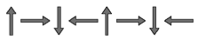
5.
__________, _________

Circle one. Growing OR Repeating

Rule: ______________________________________________

Part 2: Do the following show equality? Yes or no?

1. 32 + 1 = 32 x 1 ___________

2. 7 x 3 = 3 x 7 ___________

3. 16 x 0 = 14 – 14 ___________

4. 21 + 8 = 5 x 6 ___________

Patterns HW
THURSDAY
Part 1: Write the rule for each pattern below. Then fill in the next two numbers.

1. 17, 23, 29, 35, _______, _______ Rule: _____________

2. 75, 100, 125, 150, ______, ______ Rule: _____________

3. 10, 40, 70, 100, _______, _______ Rule: _____________

4.
__________, __________

Circle one. Growing OR Repeating

Rule: ______________________________________________

5. _______, _______

Circle one. Growing OR Repeating

What would be the 20th figure if the pattern continued? ______

Review
Part 2: Complete the related facts below.

6. 27 ÷ 3 = ____ 7. 7 x 8 = ____

www.forrestmath.weebly.com
Name _________________________________
MONDAY
Part 1: Write the rule for each pattern below. Then fill in the next two numbers.

1. 99, 96, 93, 90, _______, _______ Rule: _____________

2. 73, 63, 53, 43, _______, _______ Rule: _____________

3. 1, 2, 4, 8, _______, _______ Rule: _____________
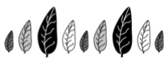
4.

_______, ________

Circle one. Growing OR Repeating

Rule: ______________________________________________
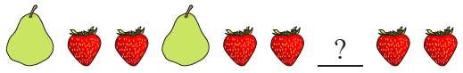
5.

What piece of fruit belongs in the blank? __________

If the pattern continues, what shape would be 15th? _________

Review
6. Circle each of the following that shows the identity property of addition or multiplication.

14 + 0 = 14 7 = 0 + 7 8 x 0 = 8

2 x 8 = 16 12 x 1 = 12 5 + 4 = 9

7. Jayla was making bracelets for eight of her friends. She used 6 beads for each bracelet. How many beads will she need in all?

TUESDAY
Part 1: Write the rule for each pattern below. Then fill in the next two numbers.

1. 47, 51, 55, 59, _______, _______ Rule: _____________

2. 35, 50, 65, 70, ______, ______ Rule: _____________

3. 110, 112, 114, _______, _______ Rule: _____________

Part I: Fill in the next two figures for each pattern below.
4.  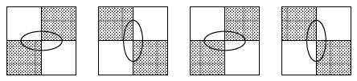 | _________, _________
5.  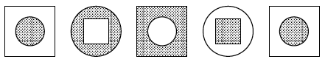 | _________, _________

6. Circle all of the following that are true.

8 x 4 = 20 + 12 15 x 2 = 30 ~ 2
24 + 6 = 3 x 10 12 ~ 4 = 12 - 3

16 ~ 4 = 4 + 4 25 + 10 = 7 x 5

Write each of the following in standard form.

7. two hundred sixty-four thousand, five hundred nineteen
_________________________________

8. fifty-four thousand, six hundred twenty-nine

___________________________________________

