**Name _______________________________________**

**TUESDAY**

**Part 1: Write what fraction of each shape is shaded.**

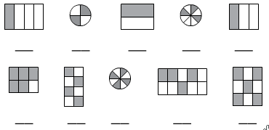

**Part 2: Shade the figures to show the fraction below it.**

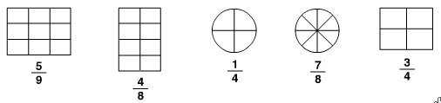

**Review**

**Write the time shown on each of the clocks.**

awQ awR a

h h h

**Round each of the following to the place value below the number.**

**6,206 4,825 7,099 hundreds place thousands place tens place**

__________ __________ _________

**Fraction HW**

**WEDNESDAY**

**Part 1: Write what fraction of each shape is shaded.**

**Part 2: Shade the figures to show the fraction below it.**

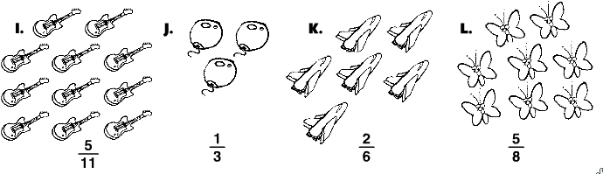

**Shade each model to represent the fraction or mixed number written below each box.**

iii

iii

**Fraction:**

**Fraction: Fraction:**

one and two fourthstwo and five eights

**Answer the following questions below.**

**1.** Rowena puts 7 socks in the washing machine. Four of them are black and 3 are white.

What fraction of the socks is black? _________________

What fraction is white? _____________

**THURSDAY**

**A fraction model is drawn inside each box. Name the fractional part that is shaded.**

EightTenths

**Fraction: _________ Fraction: _________**

**3. Shade each model to represent the fraction or mixed number written below each box.**

" " " "

**Fraction: Fraction:**

one and two fourthsthree and two tenths

**Review**

**Fill in the chart using elapsed time.**

|  |  |  |  |
| --- | --- | --- | --- |
| **Start Time** | **End Time** | **List the hours** | **Elapsed Time** |
| !  ___:______ | $  ___:______ |  |  |
| 4:05 p.m. | 8:05 p.m. |  |  |